**SENNEBOGEN Finance: Successful start - with strong conditions into 2025**

**This year, a new opportunity to finance machines and cranes in a flexible and customised way has been launched via SENNEBOGEN Finance. Together with its financing partner DLL, SENNEBOGEN Finance offers flexible, customised financing models - directly from a single source. Thanks to the positive response and various successfully implemented projects, SENNEBOGEN will continue to offer attractive conditions in 2025 in order to provide customers and dealers with the best possible support.**

**Customised financing for maximum flexibility**

SENNEBOGEN Finance offers customers the opportunity to customise their financing - from hire purchase and leasing to dealer purchase financing. The spectrum ranges from flexible terms to attractive interest rates to make the use of SENNEBOGEN machines and cranes economical and efficient.

‘Our target is not only to offer our customers excellent machines, but also the right financing to fulfil their requirements,’ explains Anton Sennebogen, Managing Director of SENNEBOGEN Maschinenfabrik GmbH. ‘With SENNEBOGEN Finance, we are creating an all-round carefree package for dealers and customers alike.’

**A strong partner for dealers and customers**

SENNEBOGEN Finance not only provides optimum support for customers, but also for dealers. Thanks to dealer purchase financing, machines can be used flexibly for short-term rentals or demonstrations without tying up liquidity.

**Successful start and forecast for 2025**

Since the introduction of SENNEBOGEN Finance, many projects have already been successfully realised. Dealers benefit from the simple and fast processing via a central point of contact, while customers gain planning security and economic flexibility thanks to customised models.

With the launch in eleven countries in Europe and the possibility of now realising financing in 15 countries, the positive development of the offer is evident.

The further roll-out of the service to Eastern Europe and beyond is already in preparation.

SENNEBOGEN Finance is also focusing on strong conditions in 2025. Attractive special offers are currently available, for example for Germany:

* Hire purchase with a 12-month term: 0% down payment, interest rate of just 0.69%
* Hire purchase with a 24-month term: 10% deposit, interest rate of 1.99%

Details of the financing offers will be communicated in a separate press release for bauma 2025.

This offer represents a further step towards providing machines and services from a single source - innovative, flexible and customer-orientated.

Further information can be found at www.sennebogen.com/en/service/finance

**Captions:** 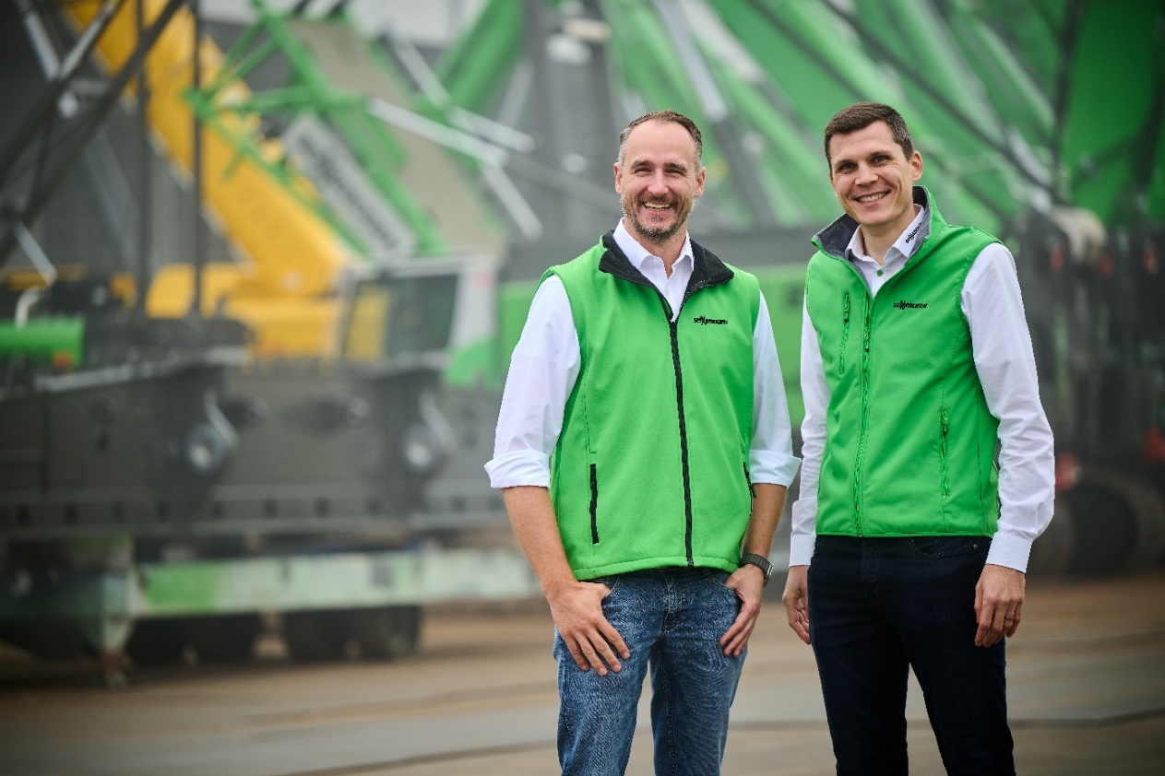

**Image 1:** Anton Sennebogen (right), Managing Director of Sennebogen Maschinenfabrik GmbH, and Christian Wich (left), Account Manager CT&I at DLL, take a positive view of the launch of Sennebogen Finance and look to 2025 with confidence.