**SENcon: The modern SENNEBOGEN control system on a new technology platform**

**Date /** Datum**:** Feb-25

**SENcon, the SENNEBOGEN Control System, is the integrated control system from SENNEBOGEN. In the latest generation, it impresses with many new, intelligent functions that support both the driver and the fleet manager and enable optimum handling of the machine - for maximum availability and efficiency.**

**Customizable driver profiles**  
Even at first glance, the new SENcon proves to be particularly user-friendly, as all basic functions can be controlled on a single, intuitive 10-inch touch display in the cab. If this is not desired or the situation does not allow it, it is also possible to assign individual functions to switches or buttons. This is just one example of the system's customizability, as the operator can use the driver profiles to tailor the machine to their individual needs. On the one hand, comfort and control elements in the cab such as the automatic climate control, the radio as well as joystick and speed settings, which increase driver comfort and concentration, can be personalized. In addition, certain machine parameters can be memorized that are common for a specific application or adapted to a specific driver, for example. This not only increases efficiency and precision in multi-shift operation or with changing tasks, but also makes the cab the personal space of the respective operator.

**Helpful assistance systems and (partial) automation**  
The new control system from SENNEBOGEN also offers various useful assistance systems that ensure increased safety and accuracy during operation: starting with the Virtual Wall, a virtual boundary that blocks the system as soon as the boom exceeds it, through to the continuous weighing of loads in the grab, which can be used to effortlessly record the handling capacity of the material handler, among other things. Machines equipped with the new SENcon are also prepared for partial and/or full automation. This means that it will be possible to automate repetitive work sequences in the future, reducing the operator's workload and increasing productivity at the same time.

**Real-time machine monitoring with diagnostic tool**  
Another important point is the machine's ability to communicate, which is reflected in the diagnostics tool. The machine provides the operator with real-time insights into the most important parameters and helps him to correctly assess the condition of the machine and achieve optimum performance in the respective situation. This enables the operator to make decisions efficiently and quickly based on real data.

By connecting the system to the SENNEBOGEN Troubleshooter, the operator can also find all the solution steps for troubleshooting directly. In addition, customer service can connect to the machine for diagnosis without having to be on site. The service technicians can offer solutions remotely or get an overview so that they can arrive with the right spare parts straight away, for example. This not only saves valuable time and service costs, but also increases machine availability.

**Wireless software updates for maximum availability**  
Another advantage of the new SENcon is that software updates can be transferred easily and conveniently “over the air”. This means that the machine's performance is always kept up to date thanks to regular and easy-to-install updates. In addition, new functions (for example with regard to automation) can be easily installed or activated long after purchase. Here, too, there is no need for on-site servicing.

**Continuous analysis and machine optimization**  
The communication capability of the control system not only ensures that the driver is informed in the best possible way, the connection with the SENtrack telematics system also provides the fleet manager with a large amount of data that allows him to analyze the machine or his entire fleet in detail. Among other things, this allows the performance and utilization of the machine and the driver to be analysed and optimization potentials to be identified. Potential energy savings and predictive maintenance work can also be derived from this.

All in all, the intelligent networking and communication capability of the new SENcon control system has created the basis for the long-term technological development of SENNEBOGEN machines - with technologies and functions that leave our customers and users all options open for the future.

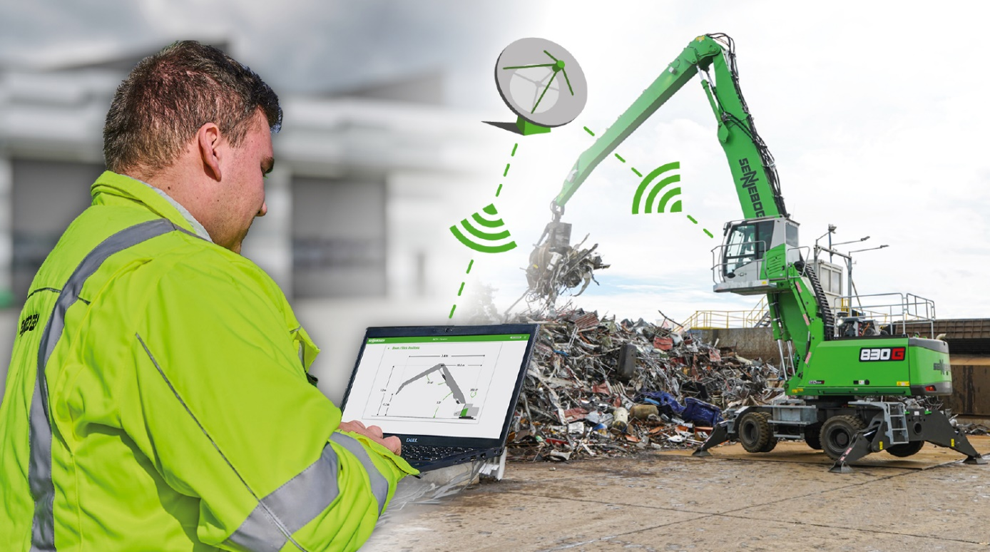**Captions**

Image 1: *The new SENNEBOGEN control system SENcon creates the basis for the long-term technological further development of the machines through its intelligent networking and communication capability.*

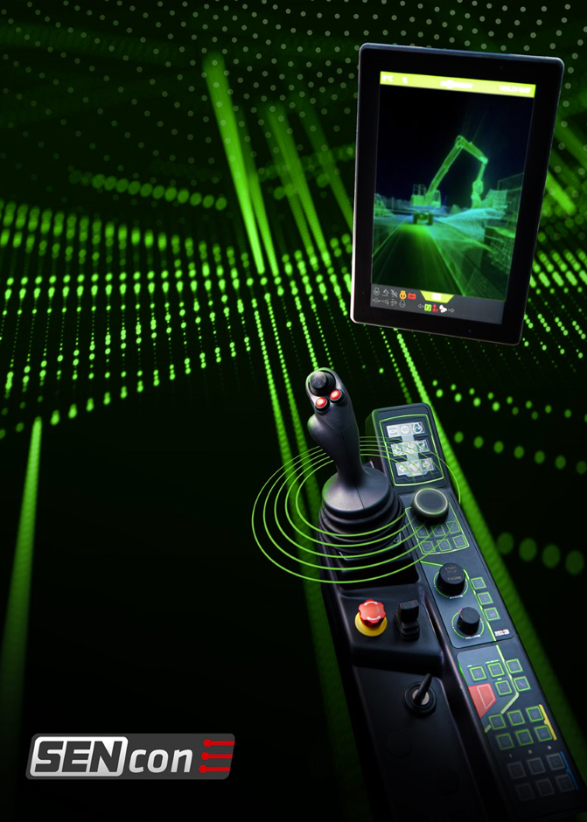  
Image 2: *Intuitive and user-friendly: All basic functions can be controlled on a single 10-inch touch display in the cab.*