**New SENNEBOGEN telescopic crane with a load capacity of 200 tons**

**Date /** Datum**:** Feb-25

**Zur SENNEBOGEN is setting a new milestone in its crane technology at bauma 2025: With the introduction of the new 6203 E telescopic crawler crane, which has a maximum load capacity of 200 metric tons and a jib length of up to 78 m, the company is expanding its range with what is now by far the largest and most powerful model in the series. A completely revised machine control system rounds off the new crane.**

Now firmly established on the international market, more and more contractors and crane hire companies are recognising the advantages and versatility of telescopic crawler cranes and are increasingly finding ways to use them. ‘SENNEBOGEN has over 33 years of experience with mobile and telescopic crawler cranes. One market trend that we are now observing is the growing demand for large telescopic crawler cranes. To meet this demand, we are now expanding our range significantly upwards with the new 200-ton crane,’ explains Managing Director Erich Sennebogen.

The 6203 E is now the tenth telescopic crawler crane model in the manufacturer's range and demonstrates its strengths above all when high capacities are required with varying radii and difficult construction site conditions. The crane is powered by an efficient 194 kW Stage V diesel engine which, like all SENNEBOGEN cranes with Stage V engines, can be easily operated with HVO if desired. The main and auxiliary winches are driven by high-pressure-regulated variable displacement hydraulic motors, which give them an impressive pulling force of 135 kN each and rope speeds of up to 115 m/min. The machine is predestined for heavy precast concrete assembly, bridge and infrastructure construction and as an agile service and auxiliary crane for the construction of wind turbines.

**High load capacities in any situation**

The 6203 E has a 6-section Pin Boom that can be telescoped up to 56.4 metres. The Pin Boom telescoping system proves to be particularly light and stable and therefore achieves outstanding lifting capacities even with long boom lengths. On the 200-tonner, an additional pin point at 90% extension on each telescopic section further increases the rigidity of the boom, which means that the lifting capacities are extremely impressive even at great lengths.

The 6203 demonstrates its capabilities with long boom lengths, but is extremely strong with short boom lengths and at angles of up to 4 degrees. This makes it particularly suitable for tasks on uneven construction sites or in pick-and-carry operation. The boom length can also be extended to up to 78 m with a hydraulically adjustable jib - an option that makes it particularly suitable for structural engineering. To keep operation as simple as possible, the most effective boom configurations are preset with 16 so-called ‘Extend Modes’. Switching between the extend modes is possible and saves valuable time when adjusting the boom length.

**High stability with great flexibility**

The telescopic crawler undercarriage has a maximum track width of 6.0 m, which can be reduced to up to 3.5 m depending on the requirements of the construction site. Thanks to the particularly robust design of the undercarriage and the high load capacities in the inclined position, the 200 t telecrane is particularly powerful, especially for pick and carry tasks, and can travel with 100% of the specified load capacity on the hook. It can also slew the specified load capacities a full 360 degrees. The 1,000 mm double grouser track shoes fitted as standard offer maximum stability and minimise floor pressure. For more sensitive surfaces, durable polyamide plates can also be used as an option to prevent damage.

**Completely revised machine control: the new SENCON Load Control SLC**

Like all large SENNEBOGEN telescopic cranes, this telescopic crane is also equipped with the tried and tested Maxcab large-capacity cab, which can be tilted by 20 degrees as standard and therefore always offers the operator an optimum view of the load. As an option, the cab can be raised hydraulically to a viewing height of 5.70 metres and tilted by 30 degrees. Cameras to the rear and to the right extend the driver's field of vision to the entire safety and working area.

An absolute highlight in terms of driver assistance is the new SLC - SENCON Load Control machine control system. To make operating the crane as comfortable as possible for the operator, a separate control system with its own screen has been integrated into the cab in accordance with automotive standards. The new system is an addition to the existing SENCON (SENNEBOGEN Control System) and provides all valuable data on the lifting process on a large, clearly organised display in addition to the load moment limitation. The extend modes can also be conveniently set here. There is furthermore a floor pressure display calculated in real time. Operation of the large touch display is particularly simple and intuitive and offers the driver valuable support when working with the machine. Diagnostic data on the machine and engine can still be found in the SENCON as usual.

**Easy to transport and self-assembly**

The crane has a transport width of just 3 metres without the crawler tracks and can be transported in 7 units. Once on site, the 200 t crane, like all SENNEBOGEN telescopic cranes, is able to unload itself from a low loader and assemble itself in just a few steps.

**Environmentally friendly and service-friendly**

In terms of service-friendliness, the crane shines with its tried-and-tested SENNEBOGEN technology, which avoids overengineering in line with the motto ‘keep it simple’. This means that hydraulics and electrics are still used where electronics offer no added value. The clear arrangement of all maintenance and service points as well as clear labelling of components make orientation easy and ensure that the machine is quickly available again when servicing is required. State-of-the-art engine, drive and exhaust systems as well as large-dimensioned lines and valves ensure efficient operation and protect not only your wallet but also the environment.

**Presentation at the bauma 2025**

The 6203 E will be on display as one of the new cranes at the SENNEBOGEN booth at the bauma outdoor area FM.712, Munich Trade Fair, from 7 April to 13 April 2025, where it will be presented to the public for the first time.

**Captions:**

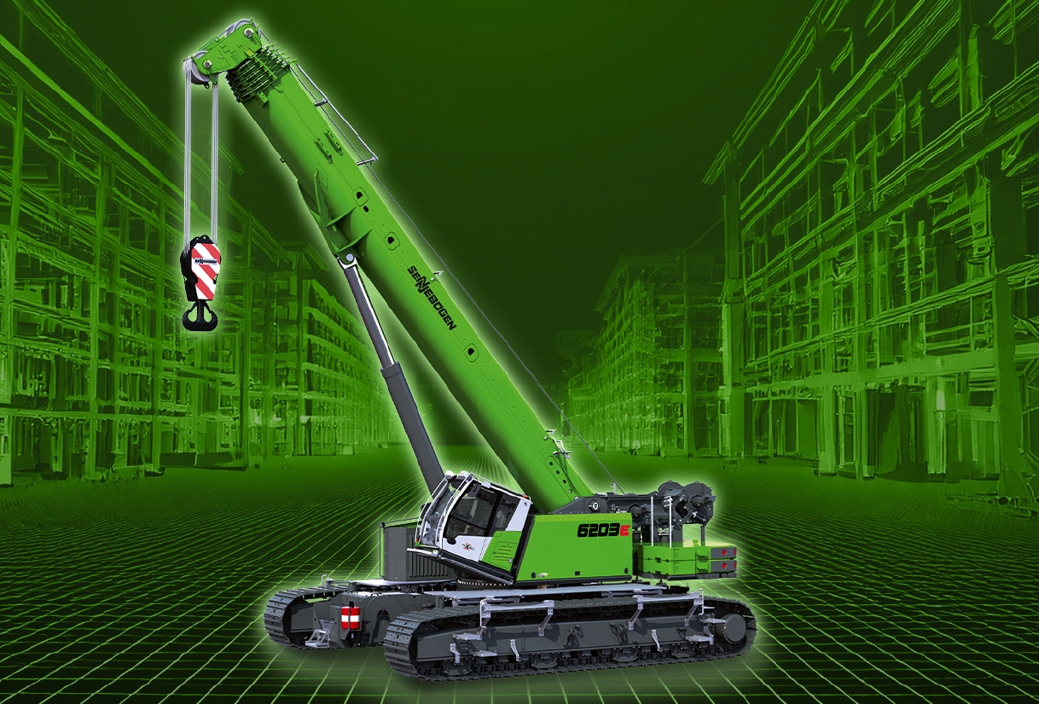

Image 1: *The new 200 ton telescopic crawler crane 6203 E from SENNEBOGEN celebrates its trade fair premiere at bauma 2025 in Munich.*

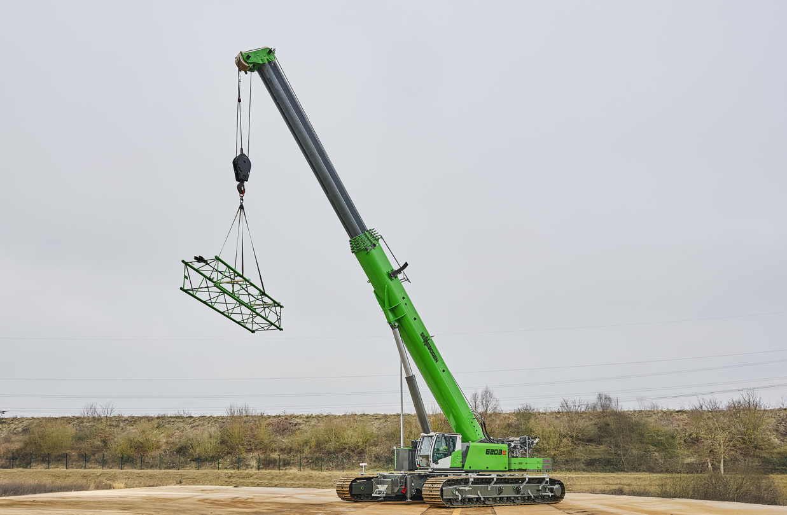Image 2: *Equipped with the 6-section pin boom, the SENNEBOGEN 6203 E is particularly strong in pick and carry tasks and when lifting at an inclination of up to 4 degrees.*