**New material handler in the G series: the SENNEBOGEN 830 G with 17 m reach**

**The new 830 G is the most versatile material handler and is suitable for many applications and uses. With its modular design and an impressive reach of 17 meters, its predecessor, the 830 E, has shaped the machine landscape in Europe for many years. Upgraded to the new machine generation of the G series, this machine now shines with many brand new features, including the new Maxcab comfort cab, the new SENcon control system and a machine design that has been completely optimized for efficiency and service-friendliness.**

**SENNEBOGEN 830 G: The all-rounder for many applications**

With its 38 t operating weight and 17 m reach, the new 830 G series is a material handler in the medium size class and, thanks to a wide range of equipment options, is an all-rounder for many areas of application. Depending on the configuration, it impresses in scrap handling as well as in recycling, timber handling or at the port. With its modular design, the 830 G can be equipped with crawler or mobile undercarriages with or without a pylon, as well as with equipment lengths from 14 to 17 m and various grabs or other attachments such as vacuum traverses. You can also choose between a compact boom, a curved banana boom for greater reach depth or a ULM stick variant – i.e. equipment with a special deflection mechanism for sorting grabs – for the boom itself. Thanks to its intelligent and robust machine design, the 830 G can cope excellently with demanding continuous operation in challenging working environments, such as extreme weather, dust or heat.

**Improved payloads, less fuel consumption**

The modern control technology of the new G series impresses with its outstanding response behavior. In addition, the working cycle is perfectly coordinated so that combined or overlapping movement of the machine is child's play and work processes can be carried out quickly and precisely – for maximum productivity and efficiency in the daily work process. In addition, the load capacity values of the 830 G-series have been significantly improved once again, so that the material handler can now lift an impressive 4.3 t at 15 m radius in the version with mobile undercarriage. This means that the 830 G not only lifts more, but also achieves a correspondingly higher handling capacity with the right attachment.

With the 186 kW Stage V diesel engine built in, the material handler operates in a particularly efficient and environmentally friendly manner. The engine, which like all Cummins Stage V engines can be operated with HVO, runs at a speed of 1725 rpm, which keeps both fuel consumption and noise emissions of the machine low. In addition, the engine can also be operated in Eco mode. Large-dimensioned lines and optimization of the multi-circuit hydraulics ensure that the pump system is relieved and maximum efficiency is achieved. The 830 G is therefore particularly efficient and resource-saving, saving around 18.5 tons of CO2 per year compared to the previous model.

**Maximum operator comfort: New cab and brand new control system**

In addition to outstanding efficiency, the new 830 G focuses primarily on the operator. They benefit from the completely redesigned Maxcab, which also belongs to a new generation. The standard cab elevation to 5.80 visual height (also 6.60 m is possible as an option) is now even more torsion-resistant and allows the driver to glide up and down even more smoothly. The comfort in the cab also leaves nothing to be desired. The comfort seat is air-conditioned and air-suspended and offers many individual adjustment options for maximum ergonomic working. The cab can be optionally equipped with the modern comfort audio system from recalm. This not only provides a high-quality communication system, but also operates Active Noise Canceling, which means that noise entering the cab from outside is reduced by up to 50 percent. The new and powerful automatic air conditioning system and a total of 10 built-in air vents ensure an absolutely comfortable temperature all year round. In addition, the elimination of the B-pillar has further improved the feeling of space in the spacious cab. Another particularly convenient and safe feature is that there is no battery disconnect switch and the machine is de-energized by removing the key from the ignition. The cab also offers many other amenities, including charging sockets for smartphones, an integrated cool box and a radio with hands-free function as well as Bluetooth and USB functions. All this turns the new Maxcab into the driver's very own personal comfort zone.

Another highlight is SENcon, the latest generation control system. This impresses with many new, intelligent functions, which can all be controlled intuitively via a single, 10-inch touch display in the cab. First of all, it is highly customizable, from individually created driver profiles to the assignment of individual functions to buttons or switches. There are also various useful assistance systems that support the driver in his daily work and prepare the machine for partial and/or full automation. On the one hand, the communication capability of the material handler ensures that the driver is informed about the machine status and performance in the best possible way and can therefore make decisions based on real data. Connection to the SENNEBOGEN Troubleshooter and remote maintenance options for customer service reduce on-site service calls, increase availability and save money. On the other hand, the fleet operator also receives a large amount of data that can be used for predictive maintenance and performance optimization, for example. Software updates are conveniently available “over-the-air” with the new SENcon. More detailed information on the new SENcon control system can be found in a separate press release: <https://www.sennebogen.com/en/news/news-press/sencon-sennebogen-control-system-on-a-new-technology-platform>

**Service friendliness at the highest level**

The maintenance concept for the 830 G has also been further optimized and made particularly service-friendly. This includes clear and simplified access to all maintenance and service points, such as the central electrical distributor and the central lubrication system, which makes day-to-day maintenance easier. Refueling can also be carried out conveniently and safely from the ground.

**Presentation at bauma 2025**

The premiere of the SENNEBOGEN 830 G will take place at bauma 2025. Experience the new machine live at the SENNEBOGEN booth at the outdoor area FM.712, Messe München.

**Captions:**

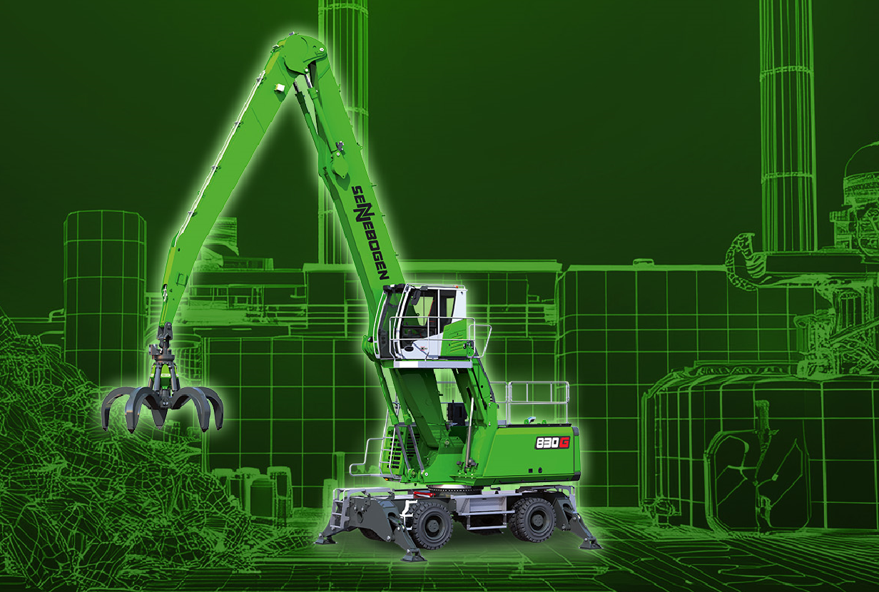

*Image 1:* New recycling material handler of the 6th machine generation with 17 m reach: The SENNEBOGEN 830 G will be presented to the public at bauma, from April 7-13, 2025 at the outdoor area FM.712 at Messe München.

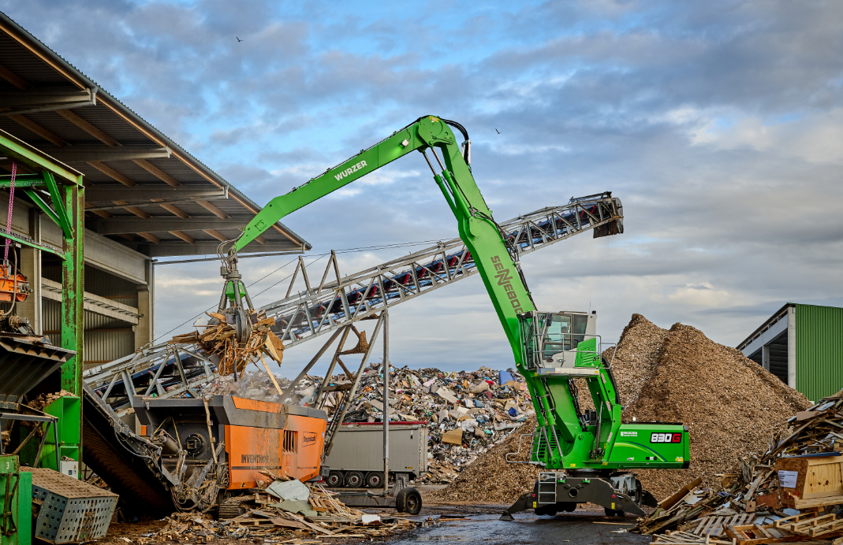 *Image 2:* Thanks to its wide range of equipment options, the new SENNEBOGEN 830 G is suitable for many industries and applications. Shown here with the Maxcab Industry industrial cab feeding a shredder with waste wood.

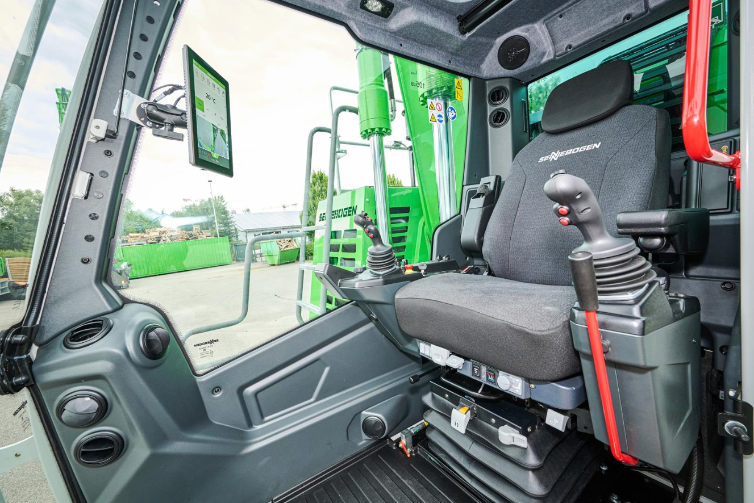

*Image 3:* The new Maxcab comfort cab with the latest generation SENcon control system ensures maximum comfort and information for the driver and the fleet operator.