**New generation SENNEBOGEN telehandler with 6 tons load capacity**

**Date /** Datum**:** Feb-25

**With the new 360 G, SENNEBOGEN is launching a telehandler onto the market that is perfectly suited to industrial applications. The robust design, combined with a load capacity of 6 t, an impressive stacking height of 8.5 m and a comfort cab that can be continuously elevated to a viewing height of 4.25 m, make the machine a unique helper in all industrial applications. The new generation of the G series sets standards in terms of operator and service friendliness.**

The 6 t SENNEBOGEN 360 G telehandler presented at bauma belongs to the new machine generation, the G series, and is a new edition of the proven 5.5 t 355 E telehandler. The further development shines with various technological innovations. It is not only the impressive performance data that attracts attention – the speeds of the work functions have been improved by up to 50 % – but also the completely redesigned comfort cab, which boasts a new operating concept. As with all machines of the new generation, special attention has also been paid to further optimizing service-friendliness.

**Compact and strong for industry: telescopic handler with 6 tons load capacity and SML power**

SENNEBOGEN telehandlers are known for combining the respective advantages of telehandler and wheel loader technology in a robust and intelligent way. The term SML-Power stands for the best power transmission thanks to the Z-kinematics familiar from wheel loaders as well as the multifunctional use of the machine thanks to a wide range of attachments and the maneuverability of the telehandler concept. With its robust steel construction and compact dimensions of 5.79 m long and 2.55 m wide, it achieves an impressive stacking height of 8.5 m and lifting capacities of an impressive 6 tons. With its long wheelbase of 3.31 m and the low center of gravity of the entire machine with an operating weight of 12.5 t, the new SENNEBOGEN 360 G stands more securely than any other.

The fact that the 360 G is robust down to the last detail is demonstrated by the high-strength, solid steel construction of the basic machine. The telehandler is equipped with a heavy-duty axle as standard, which is particularly suitable for heavy loads in industry. In addition, the sophisticated design of the boom ensures that the body can optimally absorb the forces that occur. This also ensures reliability and durability in the demanding multi-shift operation that is common in industrial applications. The powerful working hydraulics and delay-free signal processing between the joystick and main control block guarantee sensitive operation of all hydraulic functions of the machine – for shorter cycle times and better handling performance. In order to be equipped for a wide range of applications, the auxiliary hydraulics with a flow rate of up to 180 l/min are included as standard for quick and easy connection of attachments.

**Always full power and productivity: clever drivetrain and optimum motorization**

The 360 G is equipped with a modern 123 kW diesel engine of exhaust emission stage V. The traction drive is generously supplied with power at all times thanks to the coordinated diesel engine and hydraulic pump unit. Thanks to the intelligent control system, the drive motor automatically ensures the optimum setting for the system. During rapid road travel at maximum driving speed, the engine speed is reduced automatically. This ensures the best driving dynamics and economical consumption at the same time. On the other hand, the machine automatically operates at a high torque when tackling a gradient or picking up heavy material. The high speed and 91kN tractive and pushing force ensure fast work cycles. Together with the reduced refueling stops, the 360 G therefore guarantees maximum productivity, even in tough continuous operation.

**Multicab: comfort cab with new operating concept**

The new cab of the SENNEBOGEN 360 G enables concentrated and relaxed work thanks to an operating concept that adapts individually to the operator. A central touch display replaces conventional toggle switches and allows intuitive settings according to personal preferences. Protected from noise and vibrations, the driver can concentrate fully on his work. The excellent visibility and ergonomically arranged, swinging controls ensure an optimum working environment. Numerous storage options, modern connections (USB, 12 V, 24 V) and air conditioning as standard make working a personal comfort experience.

The standard cab elevation to a viewing height of 4.25 m is an absolutely unique feature of SENNEBOGEN telehandlers. This gives the driver the best possible view when loading containers or trucks. In addition, the large window elements without a B-pillar ensure increased safety when working and maneuvering, as the driver has a 360 degree all-round view and a clear view of all four tires thanks to the large windows and the elevated seat position.

**Multifunctional and service-friendly**

With the new, more powerful machine size, SENNEBOGEN is primarily targeting customers from industry and the demanding material handling or recycling sectors. A wide range of attachments, from buckets to hydraulic or mechanical pallet forks, can be operated at the touch of a button or you can work in trailer mode. Like all SENNEBOGEN machines, the 360 G can be configured to suit the application: The selection of equipment options is extensive and ranges from bullet-proof skylights and additional sockets for front attachments to different tire variants.

The machine also proves to be particularly service-friendly, as the SENNEBOGEN 360 G has the longest service intervals in its product category. In addition, accessibility to all components is further improved by the removable side panel of the engine compartment.

**Captions:**

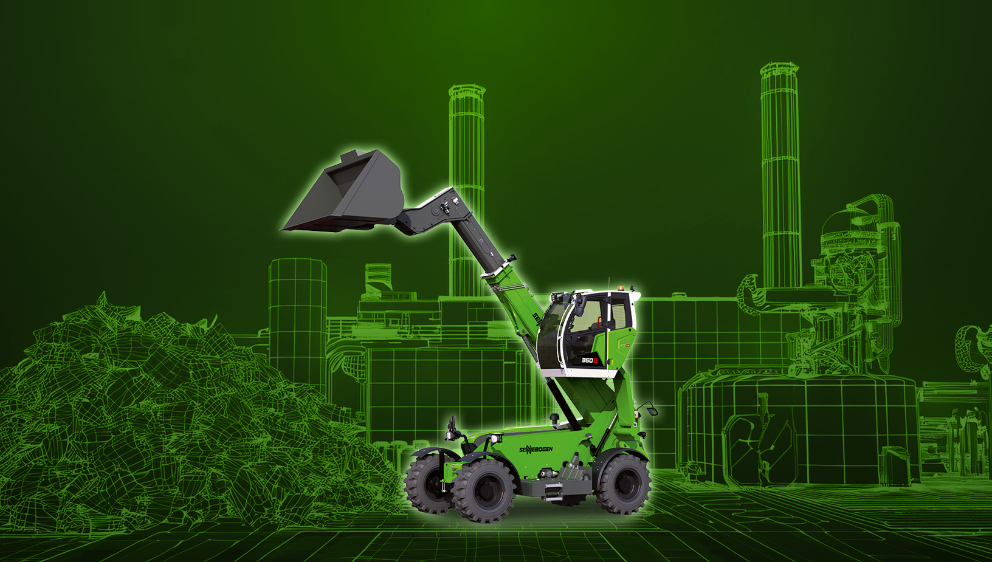

*Image 1:* With the new 6 t 360 G model, SENNEBOGEN is expanding its own product portfolio of telehandlers with a machine that is perfectly suited for industrial tasks.

*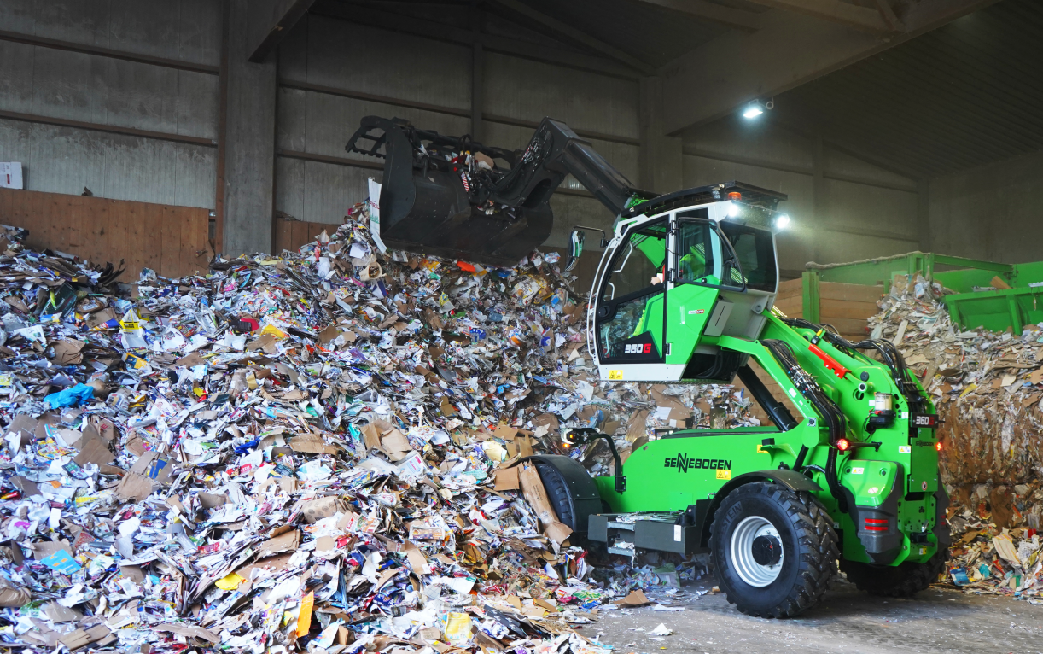Image 2:* The comfort cab, which features a new operating concept and can be raised to a viewing height of 4.25 m, makes the SENNEBOGEN 360 G unique among industrial loaders.