SENNEBOGEN expands and constructs parking garage at its plant in the Straubing harbor
SENNEBOGEN continues its growth and is building its own parking garage at the site in the Straubing harbor to provide sufficient parking spaces for its employees.
Over the past 7 years, SENNEBOGEN has experienced an average annual growth rate of 10 percent in its workforce. Although the parking lot has already been expanded twice since the inauguration of the plant in 2008, the company found the need to create additional parking spaces again last year.
As further expansion of the parking lot on the existing property was not possible and additional surface sealing was to be avoided, the shareholders agreed: a parking garage must be built upwards. The new parking garage will offer nearly 400 parking spaces across three levels, representing a net increase of over 250 spaces compared to the existing employee parking lot. With a floor space of 3,300 square meters per floor, the parking garage will provide comfortable weather protection on all levels, shaded parking in summer, and snow-free spaces in winter.
Preparations for construction began in April, followed by foundation work in June and assembly starting in July. The project is scheduled for completion in November. SENNEBOGEN is collaborating with two experienced partners on the project: Max Bögl and Koch-Generalplaner. During construction, the SENNEBOGEN 5500 crawler crane with a lifting capacity of up to 200 tons will be used to lift heavy steel and concrete components. With the construction of the new parking garage, SENNEBOGEN remains committed to its dedication to the region and the creation of optimal working conditions for its employees while continuing to drive its growth forward.

Caption:
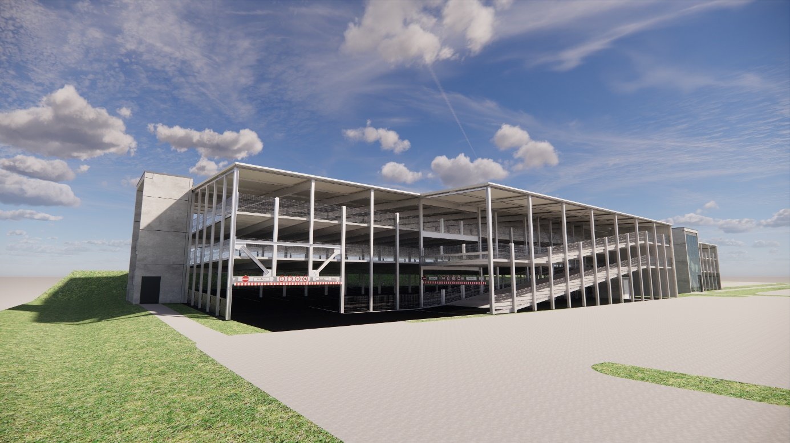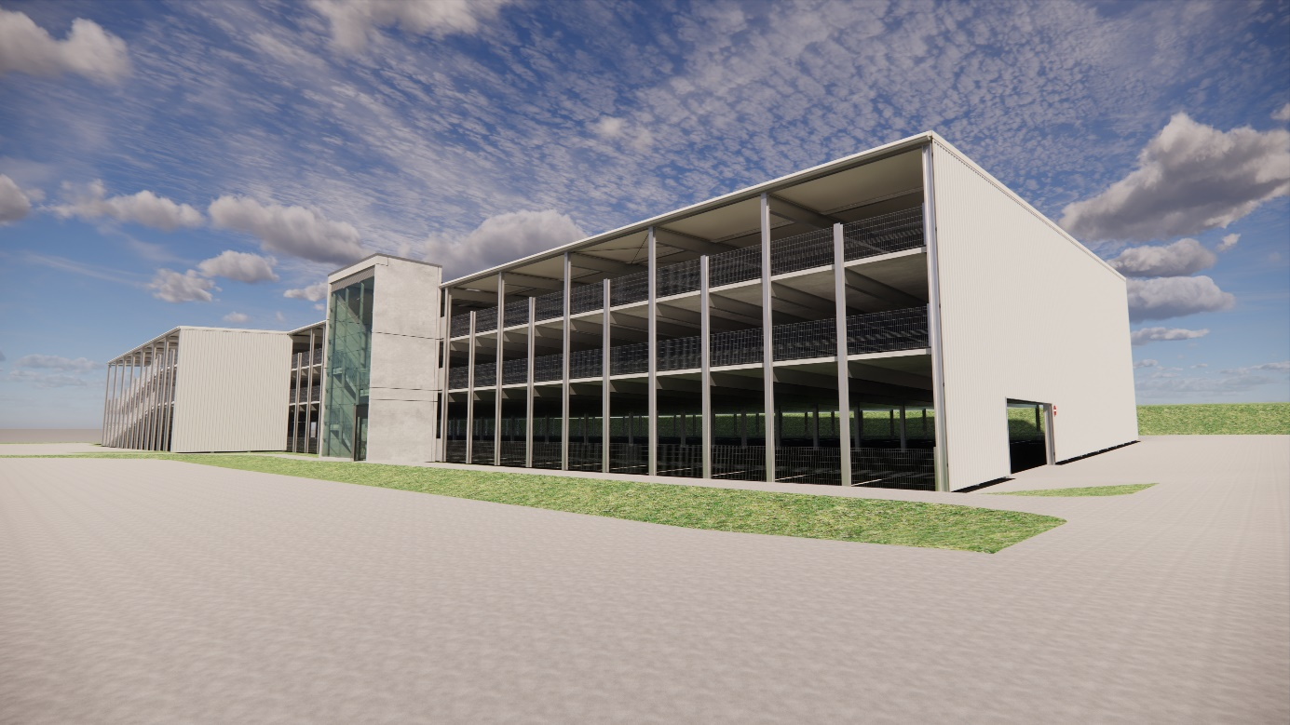
Visualizations of the new SENNEBOGEN parking garage illustrate its dimensions.

