SENNEBOGEN at the world's largest forestry demo event and industry get-together: KWF Conference 2024
Visit us from 19.06 to 22.06.2024 at the 18th KWF Conference in Schwarzenborn, Hesse, the world's largest forestry and forestry technology event in 2024. We will be presenting our 718 E and 728 E material handlers for tree care and the 340 G 4-ton telehandler on our 300 m2 exhibitor area in the open-air site, booth F0-713.
Forestry is still one of the most dangerous areas to work in. SENNEBOGEN is therefore prioritizing the topic of safety and will be showcasing its safe and innovative solutions in the areas of tree care, landscape maintenance and energy wood harvesting at the three-day event with the motto "Experience forestry". Live demonstrations of the 728 E material handler for tree care with crawler undercarriage and various attachments such as grapple saw and mulcher will be presented several times a day to illustrate our solutions.
Innovative solutions for sustainable forestry
In order to overcome past challenges, deal with changing environmental conditions and build resilient forests, innovative ideas and technology adapted to the existing conditions are required. SENNEBOGEN is facing up to these challenges and will be presenting a total of three exhibits at the event: the 718 E and 728 E material handlers for tree care and the 340 G telehandler.
SENNEBOGEN 718 E and 728 E material handlers for tree care
In addition to their impressive performance data, the compact material handlers for tree care are characterized by comfort, flexibility and safety. They impress with their space-saving dimensions, small rear swing radius and low tare weight. Outstanding safety features such as a robust full safety guard for the cab offer additional protection against falling branches. With a load capacity of 1.7 tons at full outreach, even heavy tree trunks can be handled safely – at ranges of 14 to 21 meters. Surrounding cameras ensure the best all-round visibility so that nobody has to be in the immediate danger zone of the tree. The stable undercarriage with reinforced axles and frost tires ensures a secure footing and optimum manoeuvrability, even in challenging terrain. Optional protection packages offer additional protection for the driver in the maXcab II comfort cab.
Compact and maneuverable – the 340 G telehandler
Another exhibit we are presenting is the 4-ton telehandler 340 G-series, which combines compact dimensions with high performance, reach and excellent visibility. With attachments such as the clearance profile cutter or a mulcher, the machine proves to be a real all-rounder. Particularly impressive is the Multicab cab, which can be continuously raised to an eye level of 4.10 meters and offers a 360-degree panoramic window - the most modern cab of its kind. These features ensure maximum safety when loading material and maneuvering.
Experience our exhibits from 19.06 to 22.06.2024 at the KWF conference in Schwarzenborn, Hesse, at the SENNEBOGEN booth F0-713 in the open-air site. We look forward to your visit!

Caption:
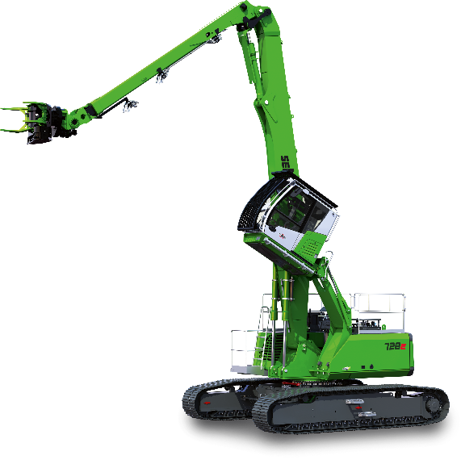
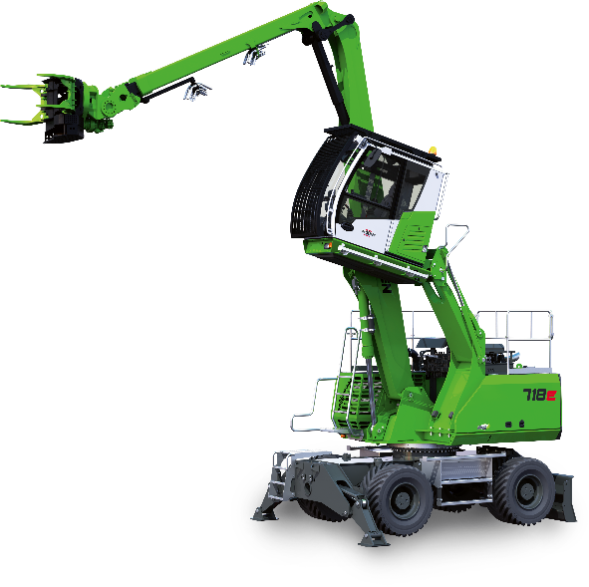

Image 1: The compact SENNEBOGEN material handlers – experience the 728 E with various attachments during the live demonstrations at our trade fair booth.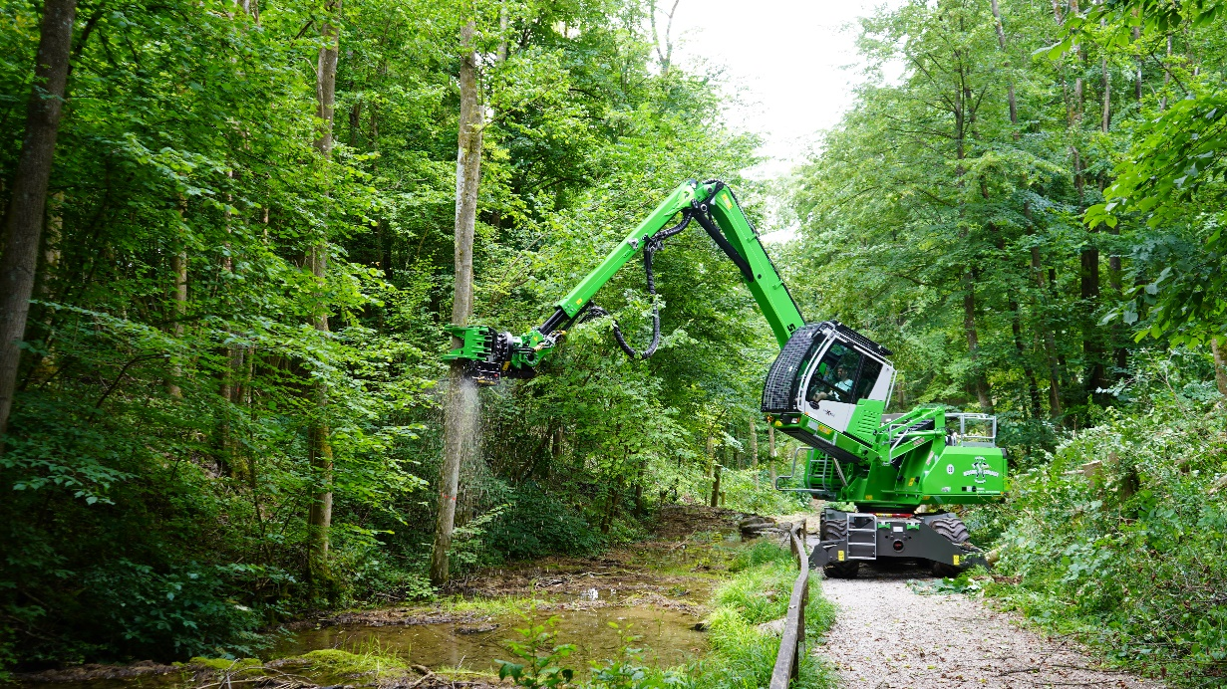
Image 2: The SENNEBOGEN 718 E impresses with its space-saving dimensions.

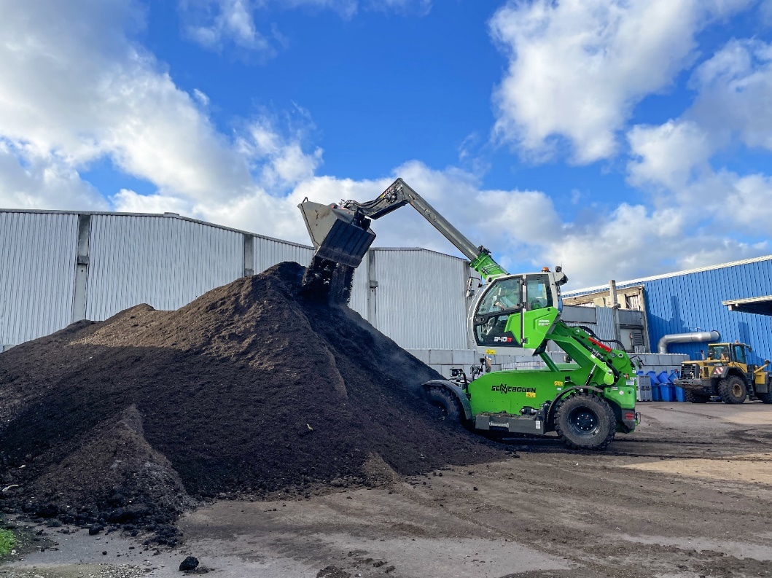
Image 3: With the SENNEBOGEN telehandler 340 G you can achieve much more than with a telehandler or wheel loader.
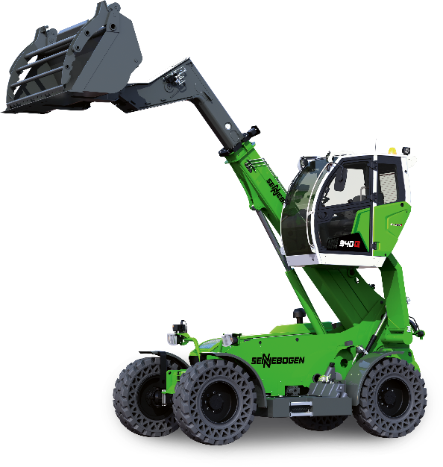

Image 4: See our all-rounder, the 340 G-series, with various attachments for yourself.

