**Editor** Autor**:** *Lisa-Maria Heigl*

**Photo** Foto**:** *German Popp*

**Location** Ort: *Deutschland*

**Date** Datum**:** *12/2024*

**Recycling company with new SENNEBOGEN 830 G series**

**Since November 2024, two new SENNEBOGEN 830 G material handlers have been strengthening the fleet of Wurzer Umwelt GmbH in Eitting. The company has been a pioneer in the fields of recycling, the circular economy, environmental protection and disposal for 40 years. With around 420 employees at its sites in Eitting, Waldkraiburg and Bichl, Wurzer Umwelt offers sustainable solutions for municipalities, companies and private individuals.**

The two new SENNEBOGEN machines will be used to feed shredders, grinders and screening plants, as well as to load recycling material onto trucks. The 830 G impresses with **stability, high performance and maximum driver comfort**.

**Machines made in Bavaria**

With its powerful performance and robust design, the SENNEBOGEN 830 G is an ideal solution for demanding recycling applications. The pendulum-mounted **800 liter polyp orange peel grab** ensures a smooth workflow through efficient material handling and precise control. With a reach of up to 17 m and an operating weight of 40 tons, the machine ensures reliable and safe handling.

The deciding factors for Wurzer Umwelt GmbH to purchase the machine were the **excellent performance during demonstrations and the test run of the prototype**, the **regional production in Bavaria** and the **short distances to the plant**, which enable fast and direct cooperation.

**SENcon system ensures intuitive operation**

One of the highlights of the **830 G** is the new **SENcon control system**. With **individual driver profiles, integrated assistance systems** such as the excavator scales, **detailed data analysis** and **an effective remote service**, the system offers a completely new level of comfort for operators, fleet managers and service personnel.

The intuitive operation makes the drivers' daily work so much easier. The **precise control behavior** and optimized **reaction speed** make material handling more efficient and enjoyable. “I am extremely satisfied with the new control system. It is much more intuitive to use than previous systems,” confirms operator Albin Gashi.

**Redefining comfort**

The new **Maxcab** is rated particularly highly by Wurzer Umwelt, with its ergonomic improvements. **A large 10” touch display, individually adjustable joysticks and an elevated seating position** provide the operator with an excellent overview of the work area. The particularly **quiet running of the machine** also contributes to a pleasant working environment.

**More power with lower fuel consumption**

In direct comparison with the machines used in the past, it is clear that the **SENNEBOGEN 830 G is more powerful, more comfortable and more efficient**. Thanks to the latest technology, not only is the performance increased, but the fuel consumption is also significantly reduced. This means a more sustainable and economical way of working for Wurzer Umwelt's recycling operation.

**Excellent service and seamless cooperation**

Another advantage for Wurzer Umwelt is the **excellent cooperation with SENNEBOGEN**. Communication with the manufacturer and the **SENNEBOGEN sales company (SVG)** is seamless. When it comes to service, SENNEBOGEN also impresses with **competent, helpful technicians** who work quickly and in a solution-oriented manner when it comes to maintenance, installation or repairs.

“Our expectations of the service support have been fully met. The improved remote service also helps to ensure that problems are solved quickly,” concludes Edwin Lambert, Plant Manager at Wurzer Umwelt GmbH.**Captions:**

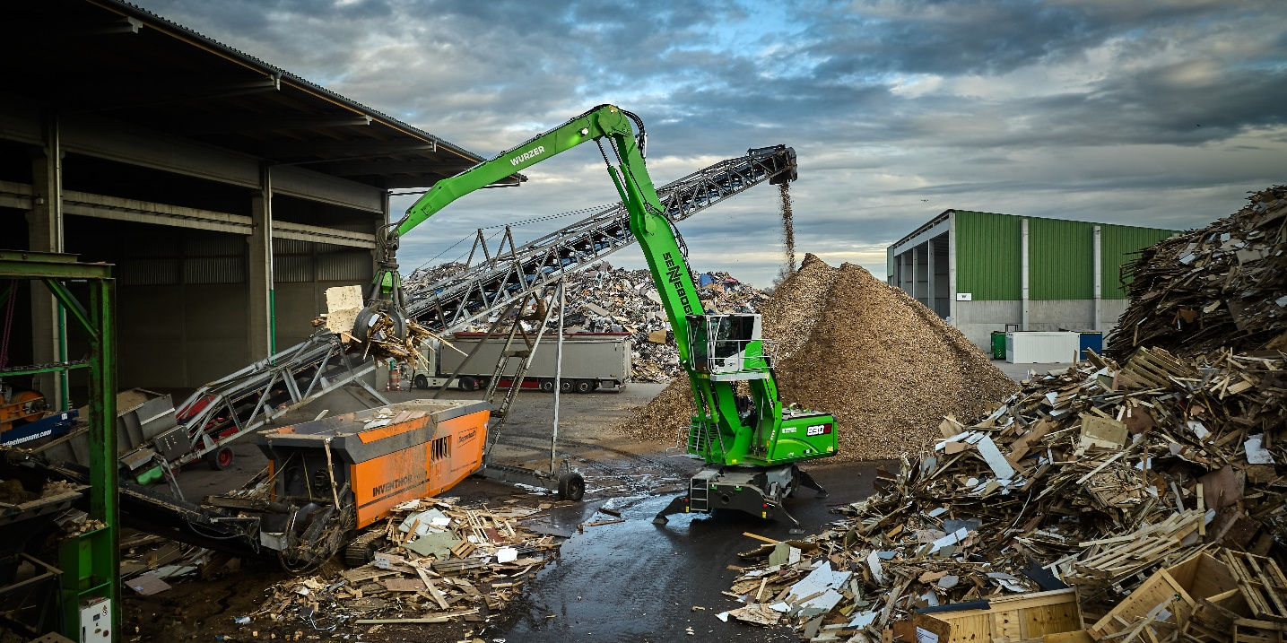

Header picture

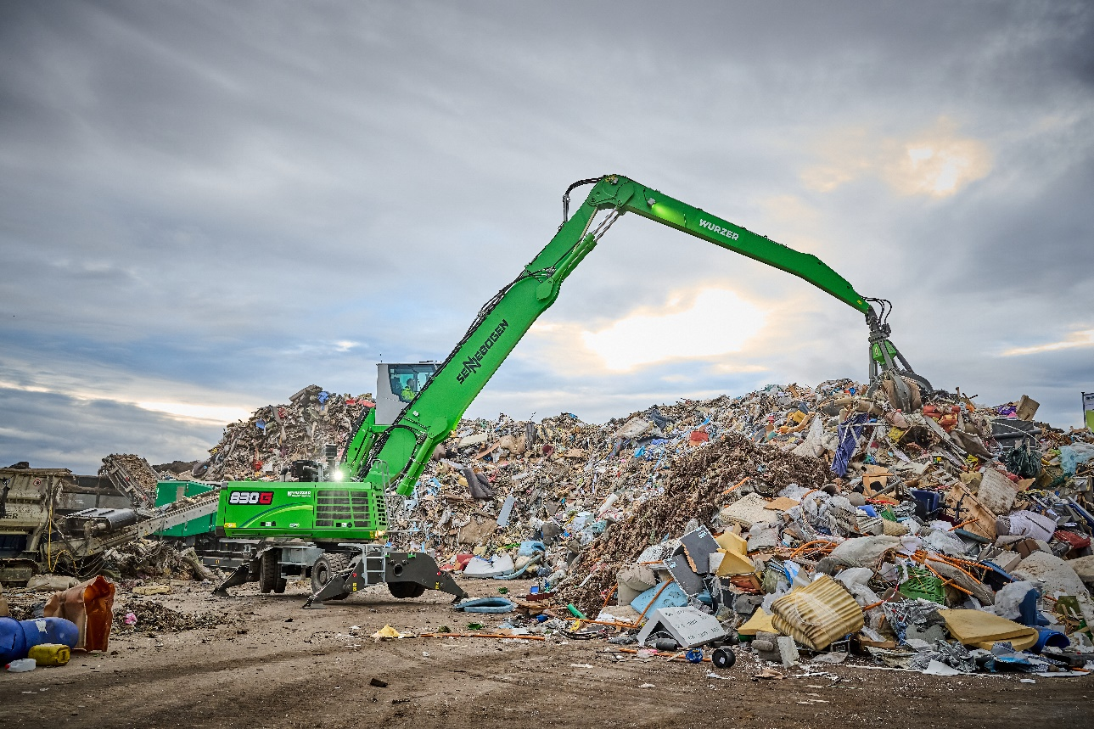

SENNEBOGEN 830 G: precise material handling with an 800 l polyp orange peel grab.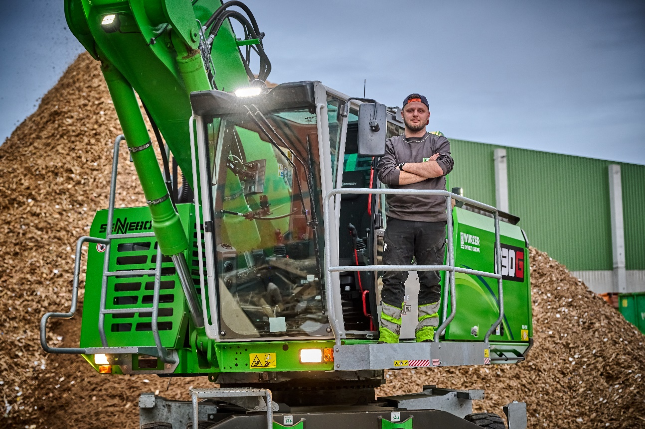

The highlight for Albin Gashi, operator of the 830 G: the comfortable cab.

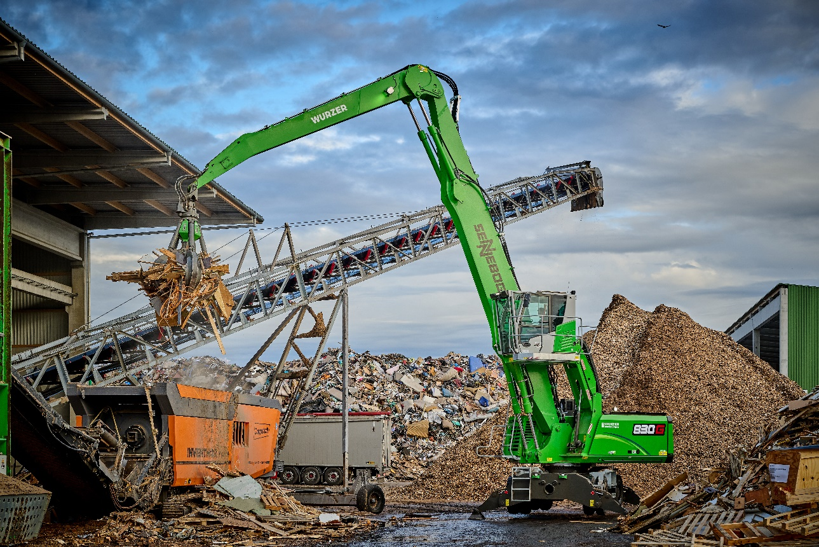

The green all-rounder feeds waste wood to a shredder at the Wurzer Umwelt site in Eitting.

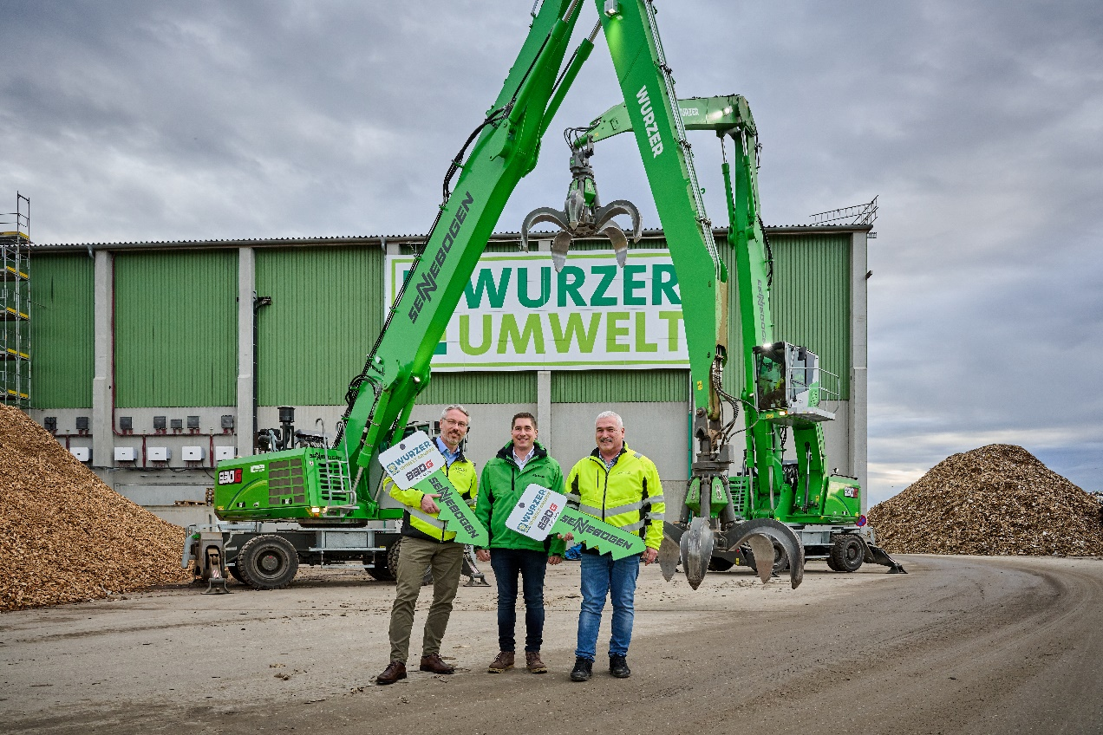

From left: Handover of the keys to the two 830 G machines with Dr. Marcus Wenzelides (Authorized Representative and Branch Manager, Wurzer Umwelt GmbH), Thomas Schmaderer (Area Sales Manager, SENNEBOGEN Vertriebsgesellschaft), Edwin Lambert (Plant Manager, Wurzer Umwelt GmbH)