tt Bild:

*Lisa-Maria Heigl*

**Photo** Foto**:** *Capture Photography*

**Editor** Autor**:** *Valérie Couplez,*

**Location** Ort: *Belgien*

**Date** Datum**:** *10/2024*

**CO2 reduction in waste management**

**The Vanheede Environment Group in Belgium stands for sustainable innovation in waste management. The company is more than just a waste disposal service provider: with a progressive approach to waste management, material recovery and green energy, Vanheede makes an important contribution to the circular economy. 98.4% of the waste collected is already recycled or used for useful applications - a proportion that Vanheede is constantly increasing through continuous investment. In line with this sustainability strategy, the company relies on the all-electric SENNEBOGEN 825 E material handler at its Rumbeke site.**

Vanheede is setting the course for even more efficient recycling with a state-of-the-art sorting plant at the Rumbeke site. The plant processes up to 100,000 tons of residual waste annually and can separate eight waste streams. Operations Manager Tom Maroy explains: “The new Vlarema guidelines require precise sorting - simple handling is no longer enough.” The precise separation of the waste streams produces purer material fractions that can be fed directly back into the circular economy. These high-quality secondary raw materials open up new applications for Vanheede and external processors.

**Advanced sorting technology for raw material recovery**

Since February 2023, the SENNEBOGEN 825 E electric with its 14-metre reach and 32.8-tonne operating weight has been supporting the new sorting plant and is a prime example of sustainable technology. The electric material handler not only contributes to CO₂ reduction, but also saves up to 40% of operating costs compared to diesel-powered models. “With its long service life and low maintenance costs, the 825 E is ideal for us,” says Lucas Ossieur, Fleet Manager at Vanheede. The decision to opt for an electric appliance fits in seamlessly with Vanheede's goal of reducing its CO₂ emissions in all areas of operation.

Another advantage: the environmentally friendly operation in the production hall protects the health of the employees, who enjoy emission-free air quality in the workplace.

**A partner with experience and reliability**

The cooperation with [SMT Belgium](https://www.smt.network/belux/nl/), which supplied the SENNEBOGEN 825 E, guarantees reliable service and fast response times - essential for the smooth operation of plants with critical goods. “We know that the service is right when quick help is needed. SMT gives us the assurance that our excavator will always be ready for use,” emphasizes Ossieur.

**The safety of employees comes first**

The SENNEBOGEN 825 E is not only efficient, but also safe. The elevated cab position offers the operator an optimum view of the filling line, making work particularly precise and safe. The cab itself is pressurized and equipped with a Hepa filter to protect the driver from harmful particles in the air. A pane of bulletproof glass protects against potential hazards from gas cylinders and ensures a safe working environment - a point that is crucial for Vanheede. “Our employees are the focus,” confirms Maroy. SMT is the first sales partner with a Sennebogen-certified training center in the Netherlands. There, eight employees were comprehensively trained in the safe handling of the 825 E and its daily maintenance.

Since its commissioning in February, the SENNEBOGEN 825 E has already completed over 1,000 operating hours and is now preparing to switch to two-shift and later even three-shift operation. “Our teams are ready to further exploit the possible applications,” summarizes Maroy.**Captions:**

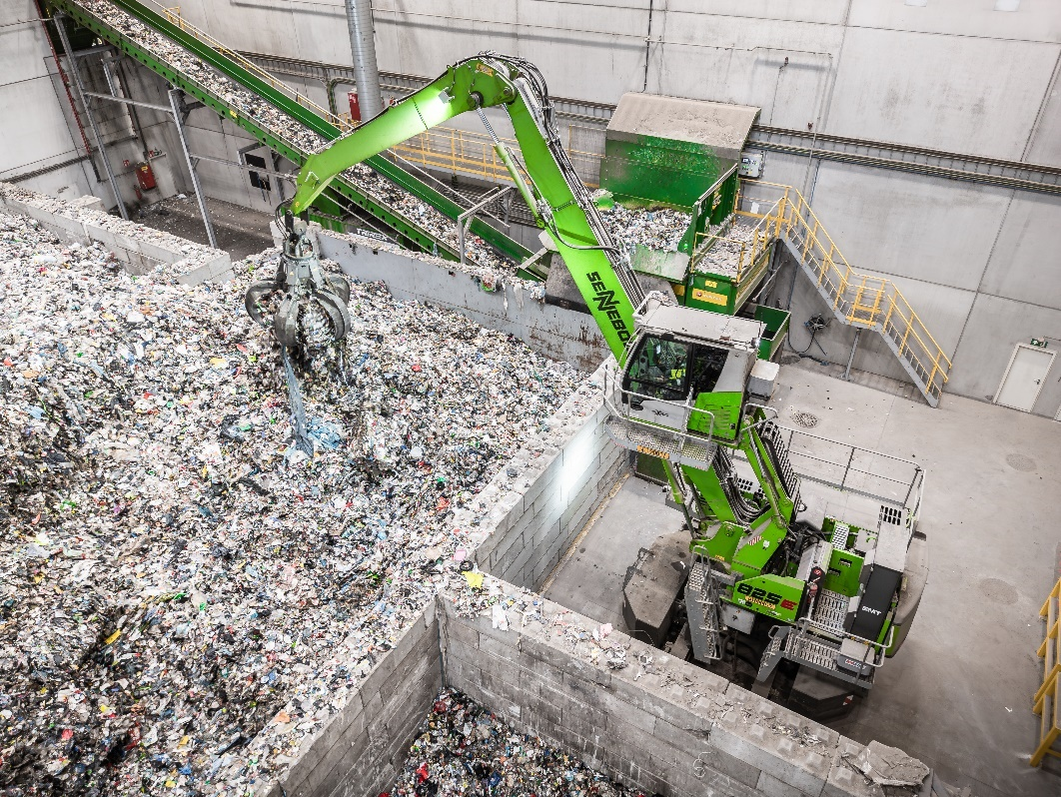

Header picture

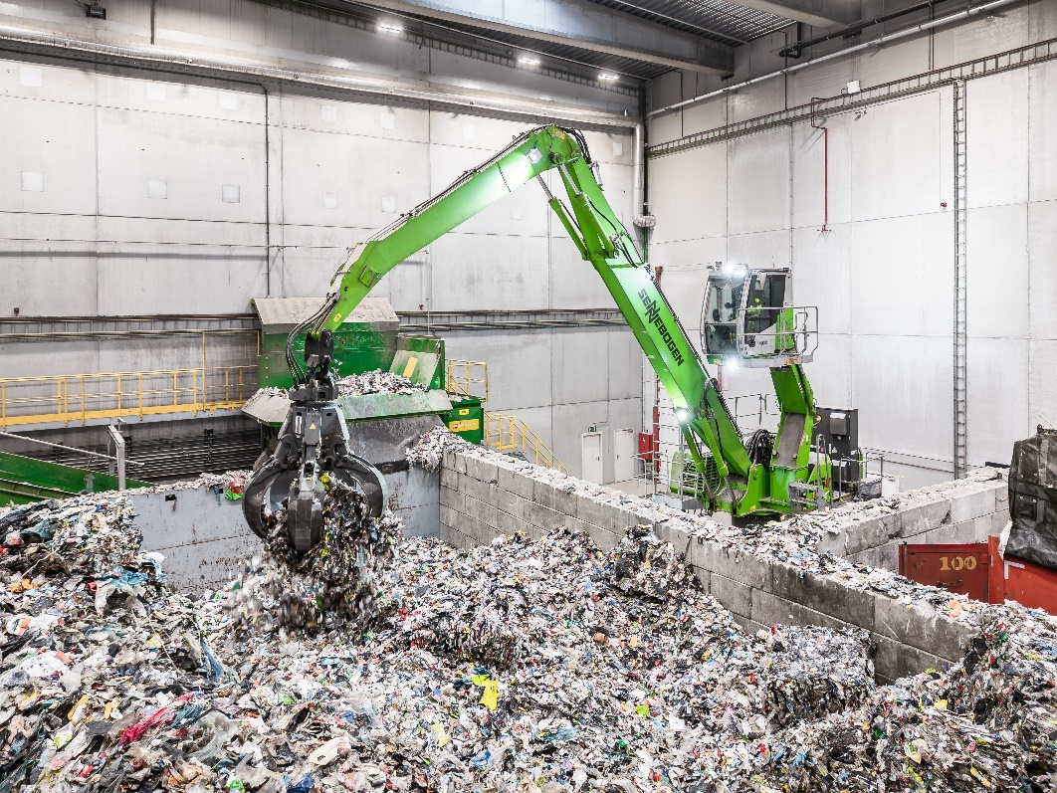

The electrically powered 825 E material handler ensures emission-free operation.

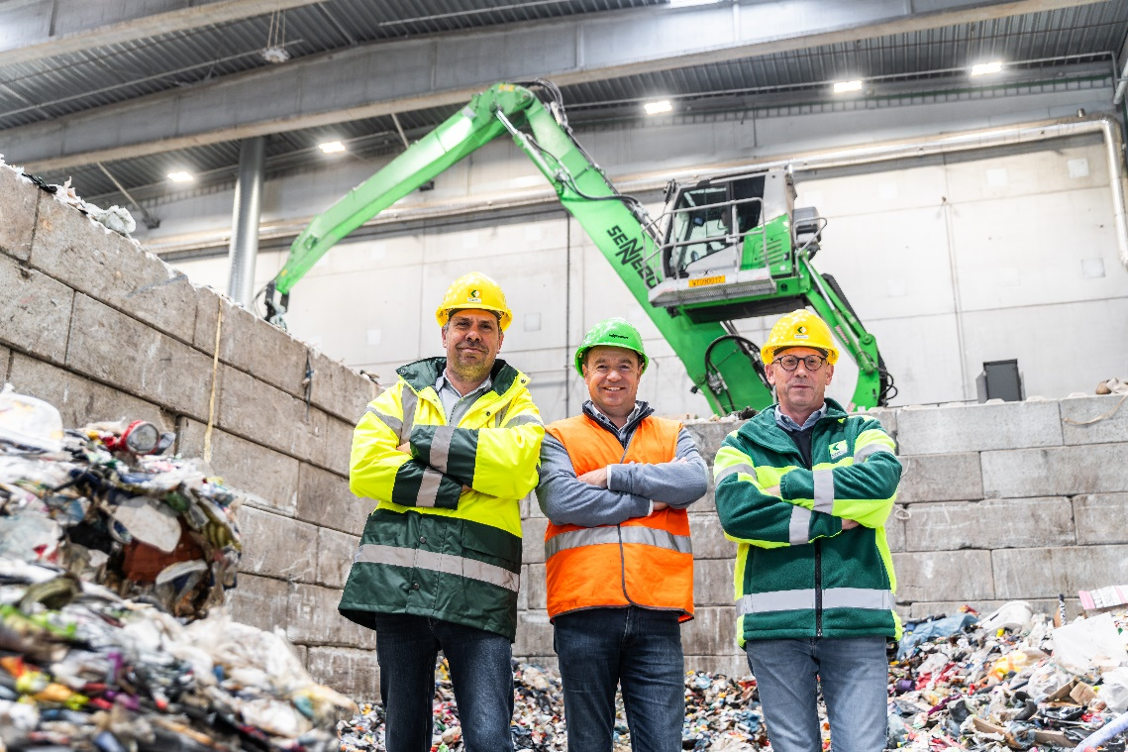

SENNEBOGEN 825 E electric in use at the Vanheede Environment Group.

**Video:**

<https://youtu.be/nfl1_QuEtTc>