tt Bild:

**Photo** Foto**:** *Lisa-Maria Heigl*

**Editor** Autor**:** *Lisa-Maria Heigl*

**Location** Ort: *Italy*

**Date** Datum**:** *10/2024*

**Sorting and loading of scrap metal**

**Cometfer is a leading Italian company in the scrap sector, supplying more than 500 companies, workshops and industrial units. As an important supplier to the major Italian iron and steel groups, foundries and refineries, Cometfer is characterized by its know-how in the procurement of scrap materials coming from various industrial activities and productions. To further increase efficiency in scrap handling, Cometfer opted for the SENNEBOGEN 825 E material handler - a decision that proved to be perfect for the demanding operating conditions. In addition to the 825 E, 8 other Sennebogen machines are in operation at Cometfer.**

The SENNEBOGEN 825 E is primarily used at Cometfer for sorting, moving and loading scrap metal. The material to be processed includes a wide range of metals such as copper, bronze, brass, aluminum and steel. Thanks to its robust construction and specialized equipment, the 825 E is optimally designed for these tasks. Daily use in one shift requires a machine that is reliable and robust - requirements that the 825 E easily meets with its modern design and powerful motor.

**Optimum features for challenging operating conditions**

The configuration of the SENNEBOGEN 825 E at Cometfer has been specially adapted to the company's needs. The machine is equipped with larger wheels on an HD undercarriage, which gives it excellent maneuverability and stability. This makes it possible to move safely and work efficiently even in confined areas. Thanks to the use of a orange peel grab and a magnet system, the material handler is ideally suited to handling both large quantities and small scrap parts with precision.

**Maneuverability as a key purchase criterion**

A decisive purchase criterion was the excellent maneuverability of the 825 E. The machine can move easily in confined spaces and even maneuver under load. These features are particularly valuable at Cometfer, as the application areas often have confined working spaces where other machines would reach their limits.

In addition, the 825 E offers a high level of stability, which enables operation without constant support. This results in time savings and increased productivity. Operator comfort has also been taken into account: The ergonomic cab provides excellent visibility and reduces fatigue, contributing to overall greater efficiency.

**Easy maintenance and low operating costs**

The Sennebogen machine is characterized by simple maintenance and low operating costs. The robust design and easy access to the service points ensure minimal downtime and a long service life for the machine. In addition, the technical support provided by customer service is fast and efficient. In the event of a machine breakdown, the 825 E is quickly made ready for use again thanks to the reliable service partnership with [Cesaro Mac Import](https://www.cesaromacimport.com/en/). Cometfer and Cesaro Mac Import have been working together successfully since 2010, with technical and commercial advice playing a key role in the purchase decision.**Captions:**

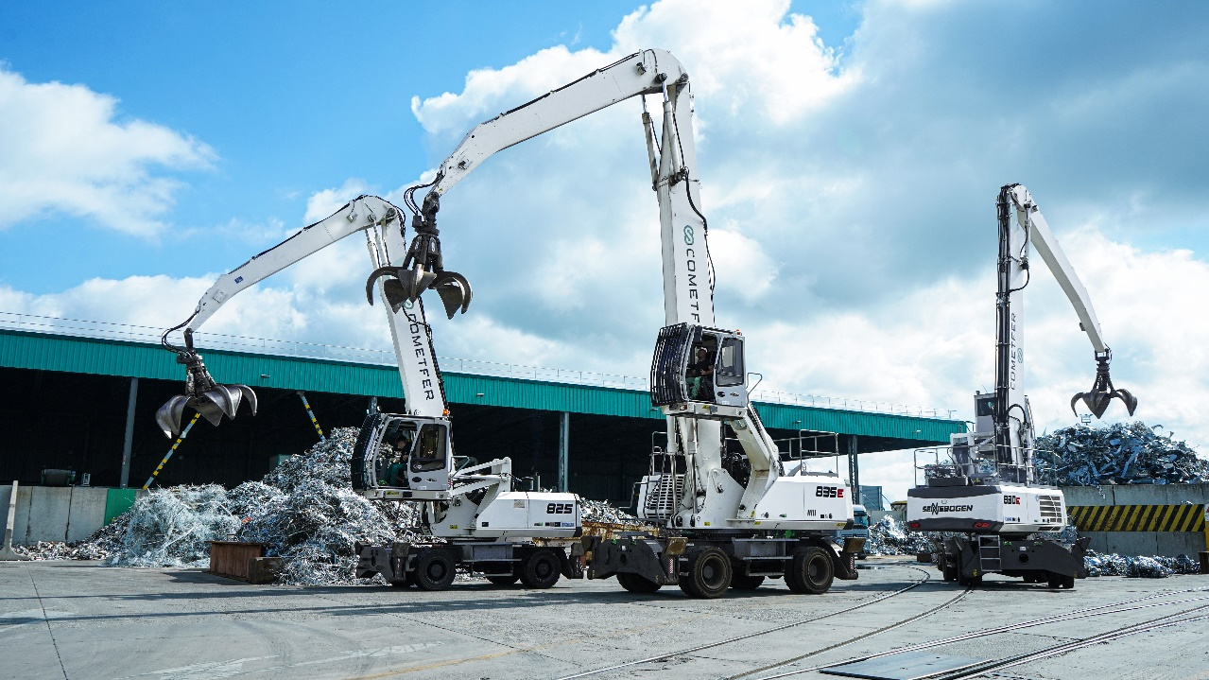

Header picture

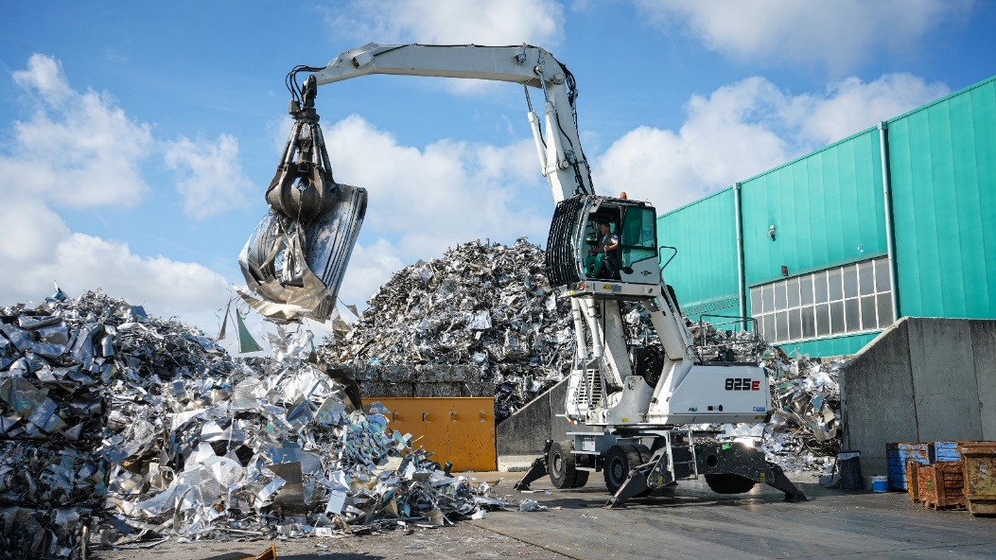

Equipped with orange peel grab and magnet system: The SENNEBOGEN 825 E at Cometfer, ready for the precise handling of scrap materials of all kinds.

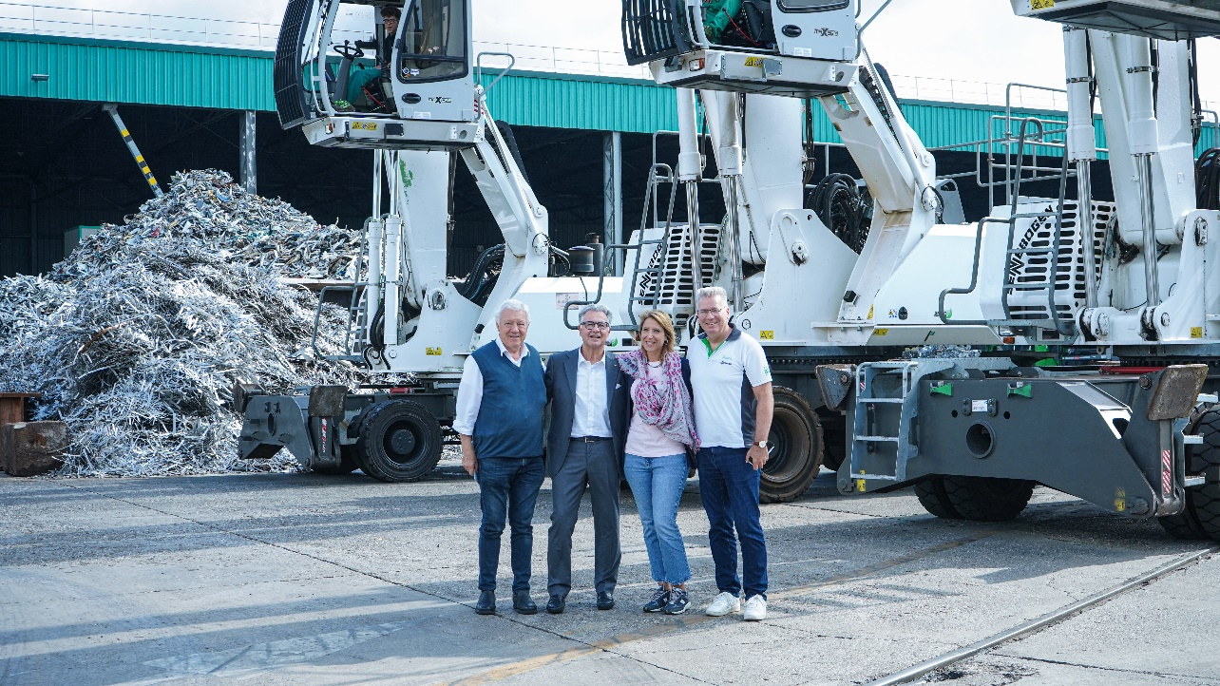

Sennebogen salesman Paolo Boscoscuro from Cesaro Mac Import, Cometfer CEO Roberto Guardafigo with daughter Giulia and Marketing Manager Michael Ibarth from Sennebogen (from left)

