Bild:
Photo Foto: Awesome Earthmover
Location: Schweiz, CH
Editor Autor: Sandra Hartl
Date Datum: 04/2024

Gantry solution in the sawmill: flagship project in Switzerland

Since winter 2023, a new rail gantry solution with a SENNEBOGEN 835 G has been in operation at the Swiss sawmill Blumer Lehmann in Gossau. As part of a comprehensive modernization of the plant, a portal crane of this dimension is being used for the first time in Switzerland at a sorting line. This demonstrates the company's clear commitment to innovation and progress.

The modern family-owned company with over 500 employees processes wood in all its facets: from timber industry (sawmill with further processing), timber construction, to silo and plant construction with locations in Switzerland, Austria, and Germany. The headquarters at Erlenhof in Gossau combines tradition and innovation: in addition to constructing a new office complex, the modernization of the log yard is also underway. The goal is to increase production efficiency while focusing on sustainability and energy efficiency.

"In a project like this, all parties involved must be well coordinated to ensure that the conversion can be completed smoothly," says Josua Preisig, production manager of the plant. He is particularly satisfied with the excellent cooperation with the manufacturer SENNEBOGEN and the Swiss sales partner, Kuhn Schweiz AG.

Challenge: Commissioning during ongoing production
As part of the new construction, an electrically operated SENNEBOGEN 835 G with an 8.6-meter track gauge was chosen for emptying the sorting boxes and feeding the sawmill. This solution is particularly advantageous for sawmills facing limited space constraints. The commissioning of the 835 G had to take place during ongoing operations, so it was decided jointly to renew the sorting line in two stages. In the first stage, the rails of the new portal crane were laid for the first 40 m of travel. With the second stage, scheduled for completion in summer 2024, the travel distance will be additionally extended by 140 m. This approach also allows the drivers to train with the new portal crane.

Focus on safety: Power supply via integrated power rail

The portal crane is supplied with power via integrated power rails in the foundation. This eliminates the need for a cable drum for power supply. The installed solution is therefore particularly safe, reliable, and easy to maintain. An important requirement for the project was visibility of the work area. The operators work at a height of 9 meters and have the entire sorting line comfortably in view. Additionally, the spacious Mastercab driver's cabin with panoramic view provides excellent visibility. "We chose the SENNEBOGEN 835 G because we were looking for a powerful, strong machine. So far, we are very satisfied, and above all, impressed with the power with which we can now carry out our work on the sorting boxes," emphasizes Preisig.

[Caption]
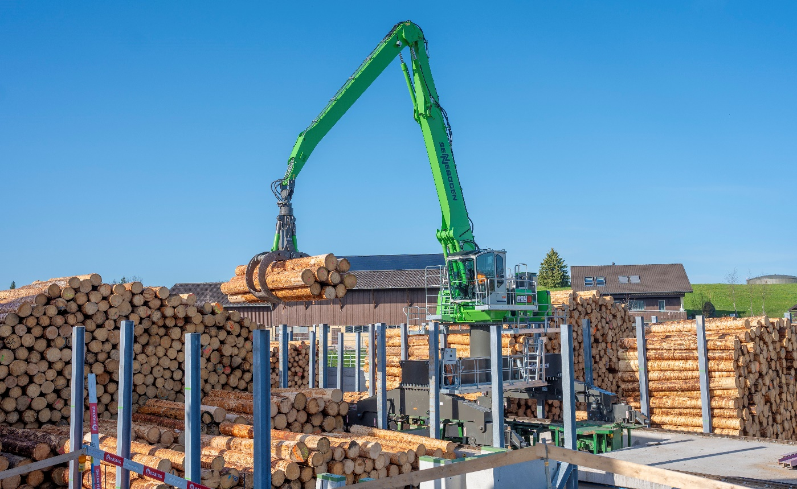
Mastercab ensures exceptional operator comfort and overview of the work area at a height of 9 meters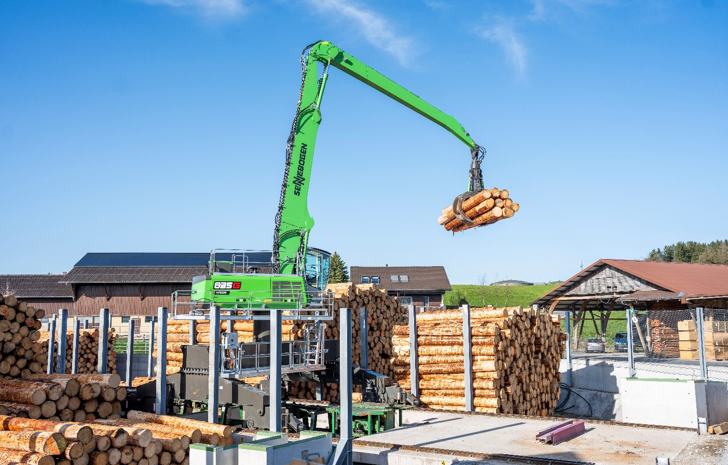
Flagship project in two stages: 40 m travel distance of the portal crane already successfully completed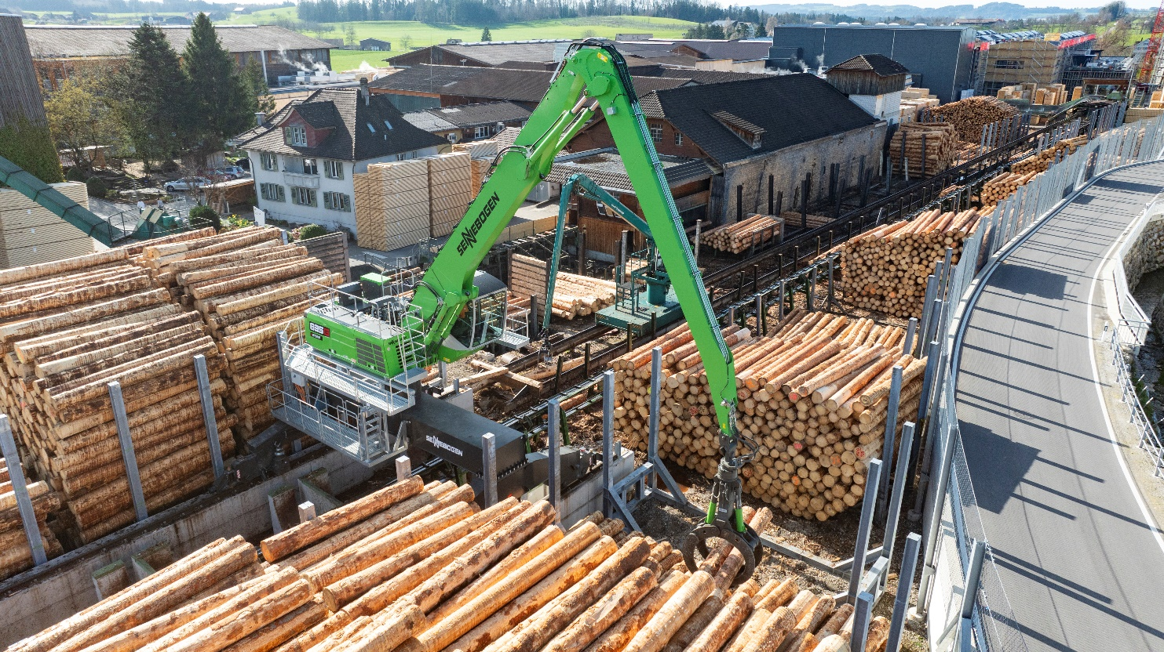
Powerful SENNEBOGEN 835 G replaces original portal crane on new sorting line with over 180 m travel distance

