Bild:
Lisa-Maria Heigl
Photo Foto: Louwers
Mediagroep
Editor Autor: Els Goethals,
Location Ort: Belgium
Date Datum: 06/2024

Metal sorting at the scrap yard

Handling machines are indispensable in the recycling of ferrous and non-ferrous metals. This is no different at the scrap metal company Van den Brouck-De Sutter in Ninove. The company has invested in three new Sennebogen machines in order to be able to handle the huge quantities efficiently.

Van Den Brouck-De Sutter, a specialist in the sorting and recycling of ferrous and non-ferrous metals, processes an average of 70,000 tons of scrap per year. Because this is no easy task, the company has enlisted the support of Sennebogen. In addition to a Sennebogen 835 E with electric drive, two mobile 825 E machines, one of which has a magnetic grab, are now working in the scrap yard.

All scrap metal is carefully sorted in order to recycle as many materials as possible. Non-ferrous metals include all metals that contain less than 50% iron, such as zinc, copper, lead, aluminum, electrical lead cables and so on. Delivered scrap ranges from smaller metal parts to complete car wrecks.

Sustainability plays an important role

Managing Director Kris Van den Brouck explains: “When we bought our new handling machines, sustainability was our top priority. Last year, we inaugurated a new two-hectare site in Ninove. The 'Doorn Noord' business park is all about a greener future. At Van den Brouck-De Sutter, we are also playing the sustainability card to the full. The decision to opt for the electric 835 E model from Sennebogen is well founded. The advanced technology - including the power of 160 kW, the reach of 18 m and the grab volume of 1 m³ - is impressive. We decided to equip the machine with an additional pylon. This makes the cab 2 m higher and gives the driver a better view when loading scrap. The fact that we save up to 50% on operating costs with the electric bagger is of course a nice bonus.”

Optimum performance - low fuel requirements

The other two Sennebogen 825E machines are diesel versions. But here, too, fuel consumption is significantly lower. This is partly due to the eco mode, the reduced idling speed and the automatic start-stop system. The new material handlers significantly increase efficiency on the construction site. Both ferrous and non-ferrous metals have shorter throughput times and can be prepared for further processing more quickly.
The operators also enjoy working with the new acquisitions. This is not least due to the high level of operator comfort, the low-noise cab and the easy access.

Reliable and competent service

“The new Sennebogen machines meet our handling requirements perfectly,” says Kris Van den Brouck. SMT Belgium, as Sennebogen's sales and service partner, has helped the company to make the right choice and advises Van den Brouck-De Sutter on the design of the machines as well as on maintenance and service.
Picture captions:

Header
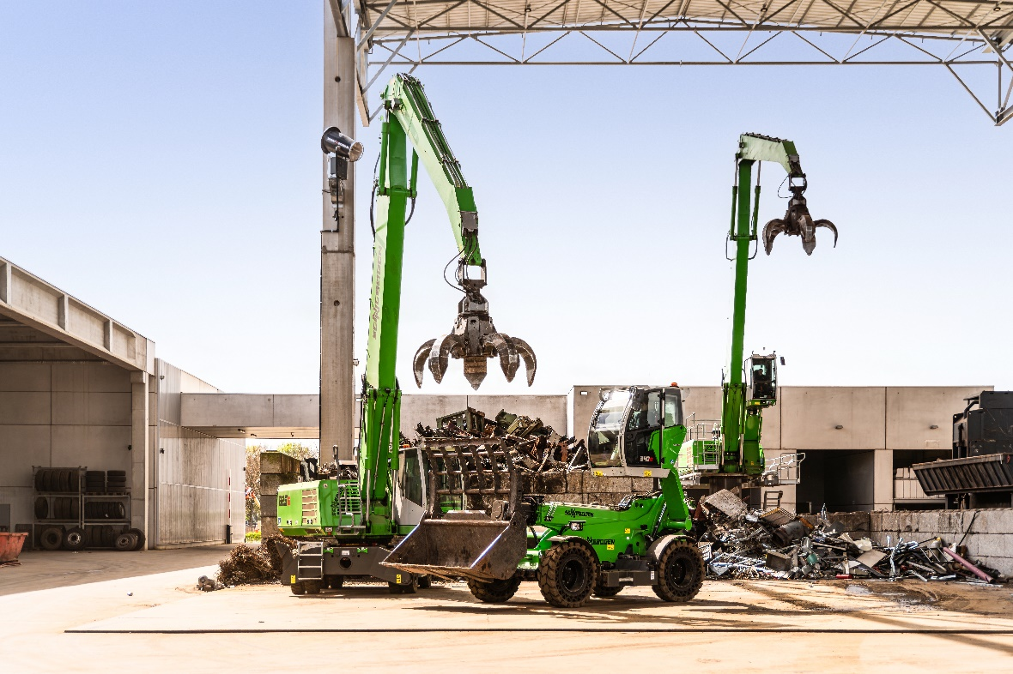

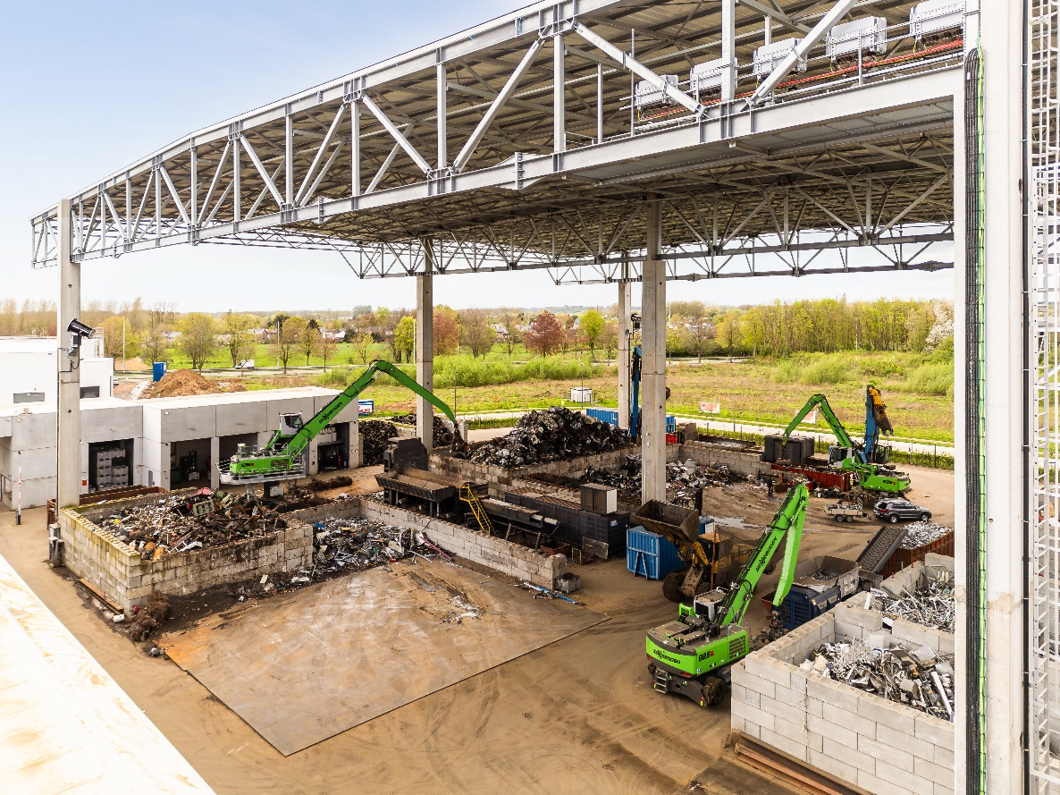
The SENNEBOGEN machines support the sorting of scrap.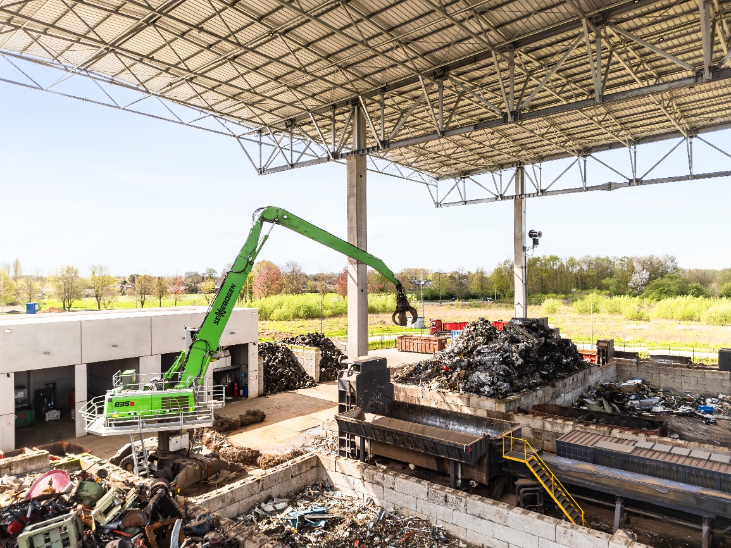
The pylon on the Sennebogen model 835 E provides a better view of the working environment.

