Bild:
Awesome Earthmovers
Awesome Earthmovers
Editor Autor: Lisa-Maria Heigl,
Location Ort: Switzerland
Photo Foto: Lisa-Maria Heigl,
Date Datum: 04/2024

REWAG relies on SENNEBOGEN machines for waste recycling

In the middle of the municipality of Kaiseraugust near Basel, REWAG Entsorgung AG relies on sustainable recycling technologies. Thousands of tons of waste, from household waste to construction and demolition waste, are recycled there every year. The work is done by several SENNEBOGEN machines - including one of the latest innovations, the SENNEBOGEN 824 G.

REWAG Entsorgung AG, founded in 1996, is a renowned waste disposal specialist that specializes in the professional disposal of all types of waste materials from companies and private households. The company operates three sites in Switzerland, including Münchenstein, Sissach and the main site in Kaiseraugust - all within a 30-kilometer radius of Basel. Its services include the acceptance, recycling, sorting and processing of waste for onward transportation.

A central credo of REWAG Entsorgung AG is to return all recyclable materials to the material cycle, while residual materials are transported away by rail and incinerated to produce electricity and heat for Basel households. The company attaches great importance to environmentally friendly disposal processes, as most of the waste is sorted manually by specialized employees and material handlers.

REWAG stands by SENNEBOGEN

24 employees work at the main site in Kaiseraugust, including five machine operators. The company recently decided to purchase a new machine, as the previous 821 E had already reached 14,000 operating hours (2,000 per year). The choice fell on the successor model, the 824 G, which has been in use since March 18, 2024. It impresses with a reach of 12 meters and an operating weight of up to 26.3 tonnes.

"We were very satisfied with the old machine. That's why it was always clear to me that we would choose this brand again," explains Operations Manager Urs Kaiser. The SENNEBOGEN machines are also easy to operate. Every operator drives every machine. Everyone is already familiar with how these material handlers work, so that each operator can quickly work efficiently with each machine.

A total of three material handlers are used for the sorting process, including the 824 G, a mobile 817 E and a stationary 821 E electric excavator in the hall.

More than just efficiency

The decision to use Sennebogen machines was based not only on their performance, but also on their environmental friendliness and energy efficiency. The machines have an efficient diesel engine with automatic idling and optimized hydraulics, as well as a SENCON control system that allows the operator to precisely control energy consumption. The Stage V exhaust system also contributes to the environmental friendliness of the machine.

The design of the new MaxCab is also impressive. Ergonomic seats and high-quality air conditioning in the spacious MaxCab of the latest generation offer good comfort. Thanks to the full-length windshield, the entire work area can also be clearly seen, which contributes to the safety of all employees.

Service easier than ever before

It's not just the ease of operation and comfort in the cab that benefits the company and its drivers. The combination of user-friendly design and outstanding customer service has made SENNEBOGEN machines the first choice for REWAG Entsorgung AG. Pascal Graff, the operator who has the main responsibility for the 824 G, emphasizes: "I really like the ease of maintenance of this machine. Many things have been optimized in the SENNEBOGEN G-series. The service, the availability of spare parts and the support from Kuhn Schweiz AG and SENNEBOGEN are the icing on the cake."
Captions:

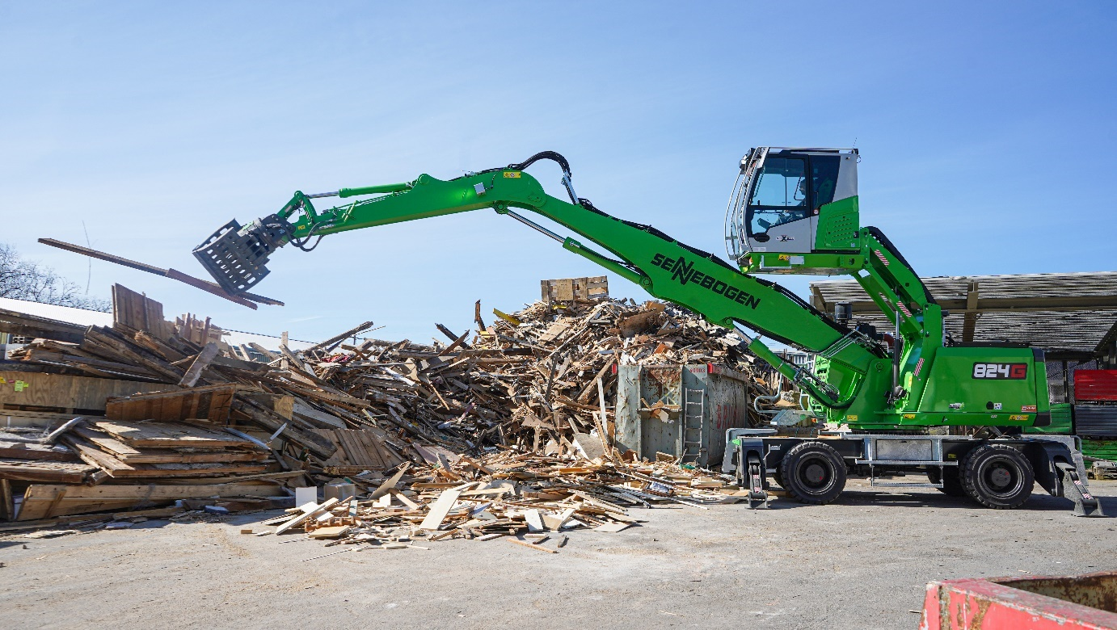
The sorting grab places the wooden spades in the designated position.

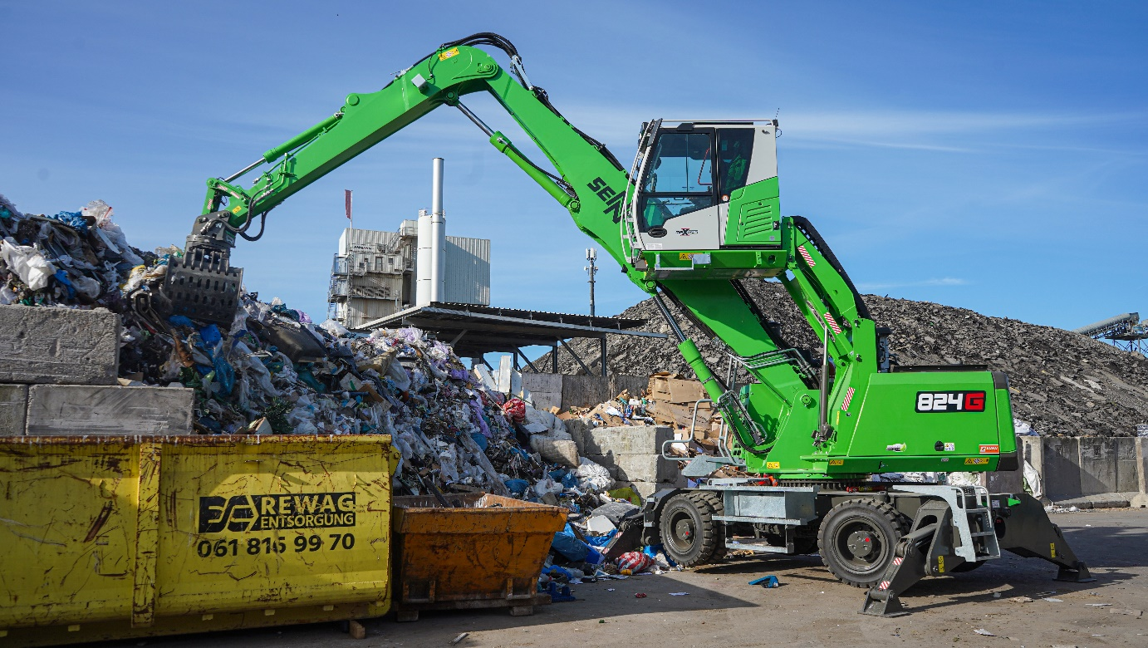
Efficient and compact - the 824 G in continuous use at REWAG.

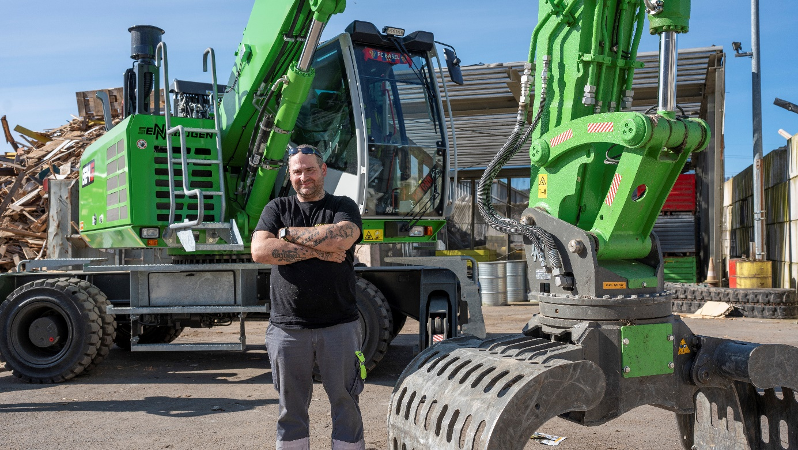
Pascal Graff: "I'm pretty proud to be operating this new machine."

