Bild:

*Lisa-Maria Heigl*

**Photo** Foto**:** *Schlüter für Bau-*

*maschinen*

**Editor** Autor**:** *Niklas Kühle,*

**Location** Ort: *Deutschland*

**Date** Datum**:** *06/2024*

**Sorting work at a recycling specialist**

**Since the beginning of the year, the vehicle fleet of the Rotenburg waste collection association in Bebra has been strengthened by two new top performers. The company has invested in a new 340 G telescopic handler and a new 822 G material handler from Sennebogen to ensure maximum handling efficiency. The robust and powerful machines are now primarily responsible for material handling and sorting work.**

The Rotenburg waste collection association was founded in 1957 and today consists of the members of the town of Rotenburg, the town of Bebra and the municipality of Ronshausen. Through inter-municipal cooperation, the task of collecting waste from the municipalities is pooled and carried out effectively. In recent years, the recycling specialist has grown steadily and now employs 27 people who process a handling volume of approx. 13,000 tons per year with various handling machines.

**Expansion of the Sennebogen fleet**

“We previously only had one telescopic handler here, and in order to relieve this and at the same time achieve a higher payload for our containers, we also opted for the material handler. At the same time, we also took the opportunity to replace the old telehandler with the new machine, which offers more safety in the work area thanks to its elevating cab, so that we now have two machines from one manufacturer here on the company premises. We hope to gain synergy effects in terms of maintenance etc. in the future,” says Operations Manager Björn Berger.

**4 t telehandler with maximum overview**

The Sennebogen 340 G combines compact dimensions with high performance, reach and the best possible overview and is the ideal solution for the refuse collection service, as it works under demanding working conditions and in multi-shift operation. Thanks to the elevating Multicab cab, the driver always has the best view of his working area at a height of up to 4.1 m. In addition, ergonomically arranged and swinging controls, air conditioning fitted as standard and large glass surfaces for a 360° all-round view offer maximum driver comfort. With a length of 5.5 m and a width of just under 2.5 m, the Sennebogen 340 G is ideal for work in limited spaces.

**22 t material handler for optimum sorting work**

With its reach of up to 10 m, the Sennebogen 822 G is also ideal for loading and sorting activities in the recycling and scrap industries. Thanks to powerful hydraulics and efficient, latest-generation engine technology, the operator benefits from maximum performance, exceptional operator comfort and low fuel consumption - perfect for demanding continuous operation.

The Sennebogen 822 G also has numerous safety features for maximum work safety: steps and access ladders provide safe access to the cab and machine components, and powerful LED spotlights ensure maximum visibility even in difficult lighting conditions, such as in the hall of the waste collection association.

**Satisfaction through excellent service**

The recycling specialist is very satisfied with the new Sennebogen machines and the associated Schlüter service: “From the introduction and presentation of the machines to the instruction, everything went very well. A huge advantage is the short distances to Schlüter and that - should there be a longer breakdown - you can also fall back on replacement machines.”

[Schlüter für Baumaschinen](https://www.schlueter-baumaschinen.de/en/schlueter-home-page) with its regional branch in Eschwege is a reliable partner for the Rotenburg waste collection association at all times.**Bildunterschriften:**

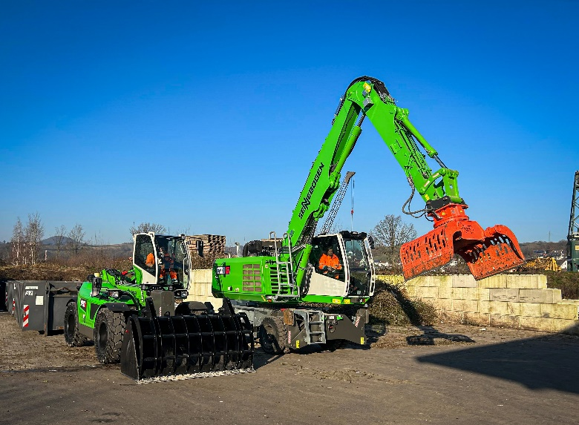

Headerbild

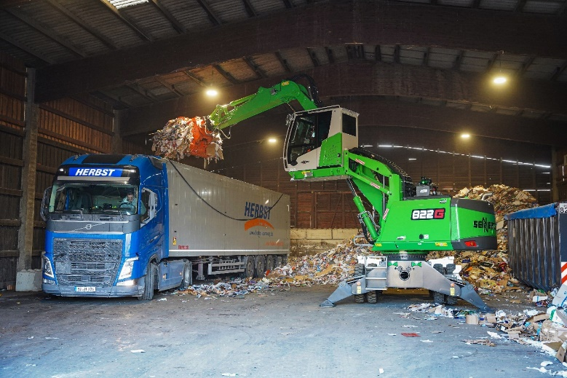

With its 10 m reach, the SENNEBOGEN 822 G effortlessly loads waste into a truck.

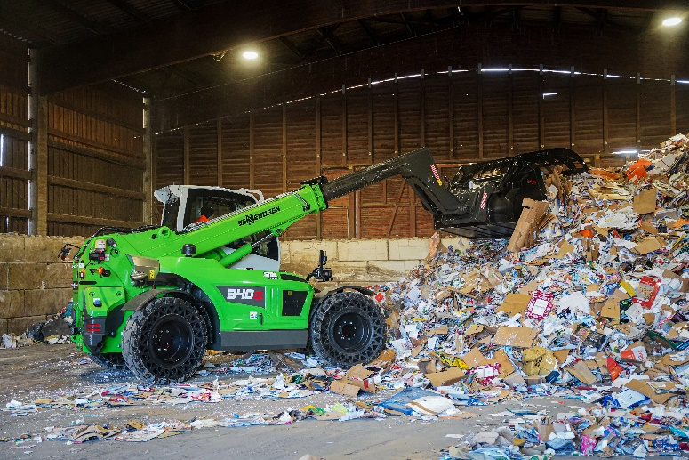

In addition to the material handler, a new 340 G is also working at the waste pick-up site.