Bild:

**Photo** Foto**:** *Selina Retzer*

**Editor** Autor**:** *Lisa-Maria Heigl*

**Location** Ort: *Deutschland*

**Date** Datum**:** *07/2024*

**Waste disposal center with SENNEBOGEN telehandler**

**The Passau-Hellersberg waste disposal and recycling center is part of the Donau-Wald waste management association. Since August 2023, the company has been relying on the SENNEBOGEN 355 E to make its daily operations efficient. The robust and powerful machine is now primarily responsible for loading paper and bulky waste onto trucks.**

Donau-Wald waste management association is the public waste management authority for the districts of Deggendorf, Regen, Freyung-Grafenau, Passau and the city of Passau. With an area of 4,500 km² and around 510,000 inhabitants in 114 towns, markets and municipalities, the association serves around 220,000 households. The association employs around 300 to 350 people in total, 15 to 20 of whom work at the Hellersberg plant.

**Disposal center collects all types of waste**

The plant in Passau-Hellersberg offers a wide range of waste disposal services. These include the disposal of household waste such as paper, organic waste and residual waste, bulky waste from private and commercial households as well as the disposal of plaster waste, waste wood, old tires and cardboard. This waste is collected on site, loaded and then delivered to various recycling plants.

**Strict schedule requires machine precision**

The SENNEBOGEN 355 E works four to five hours a day and spends more than half of the working day loading paper and bulky waste from private households. These materials are loaded onto trucks that take the recycling waste to recycling plants. Due to the large number of planned truck loads, the work is often time-consuming, tied to a strict schedule and requires precision and speed.

**The operator can monitor the loading of the truck**

The SENNEBOGEN 355 E was chosen due to its outstanding features, which make the work process considerably easier. The elevating cab enables the operator to optimally monitor the loading of the trucks and ensure that the vehicles can be filled to the limit and the materials can be compressed. The large bucket of the SENNEBOGEN 355 E has a high filling volume of up to 1,400 kg/m³, which facilitates the loading of large quantities of material.

**Short distances between dealer and customer**

Werner Reh, an experienced specialist worker, operates the SENNEBOGEN 355 E on a daily basis and is delighted with the machine's performance. He reports: “We are very happy with the vehicle. From that point of view, we can only hope that it continues like this.” The excellent service provided by the dealer [Sennebogen Vertriebsgesellschaft](https://www.sennebogen-svg.com/) is particularly emphasized: "The service for the 355 E was ideal. There was always someone available or even on site if there was a problem.” These short distances from the dealer to the customer ensure a high level of reliability and minimal downtimes.

The attachment of the SENNEBOGEN 355 E also receives praise, as it proves to be particularly efficient when handling waste. “We mainly load waste, which is great with the hold-down bucket. The attachment is incredibly good,” says Reh. These features contribute significantly to the optimization of work processes at Passau-Hellersberg waste disposal center and ensure a high level of employee satisfaction. **Bildunterschriften:**

Header

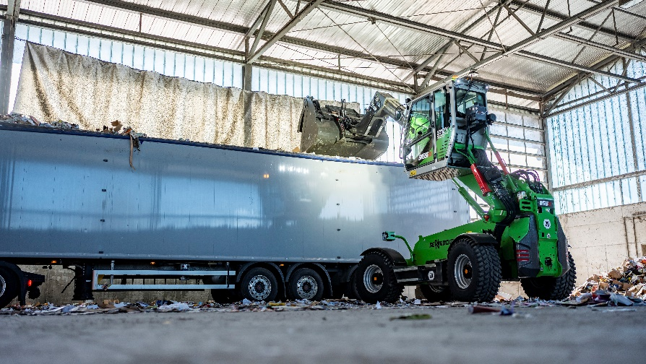

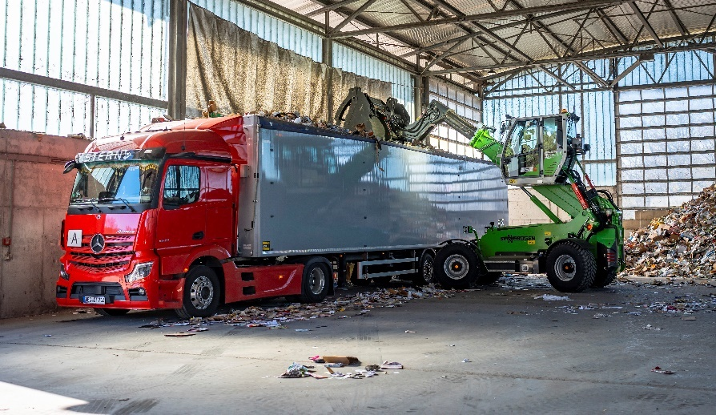

The SENNEBOGEN 340 G effortlessly loads waste into a truck with its telescopic arm.

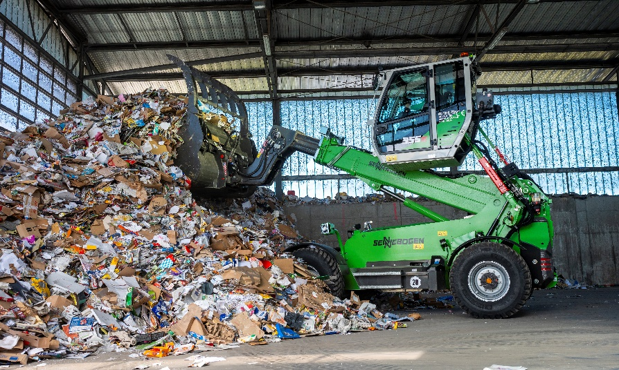

The shovel can be used to transport and load a large amount of paper waste.