Bild:
Editor Autor: Nicole Yeong
Location Ort: Deutschland
Photo Foto: Nicole Yeong
Date Datum: 04/2024

Telehandler in Fine Particles Environment: Production of Deox Aluminum Granulate

Located just around the corner from SENNEBOGEN’s headquarters in Straubing, Germany is Andomet. A subsidiary of Andorfer Sebastian GmbH & Co. KG, Andomet specializes in transforming industrial and municipal waste into specialized aluminum granules. Their state-of-the-art recycling facility sits in the Straubing-Sand area, where deoxidation aluminum (DESOX) is mechanically produced with the highest levels of purity for industrial purposes.

Eco-Friendly Metal Recycling

Sustainability is a core value for the Andorfer company. Recycling metallic materials is more cost-effective and environmentally friendly than producing new metals from ores. With a total throughput capacity of 15,000 tonnes per year, Andomet utilises their own photovoltaic (PV) systems and optimised processes to ensure very low CO2 emissions per kilogram of granulate produced. These specialized aluminum granules are essential in the worldwide steel industry, as they reduce excessive oxygen content during the steel production process.

Confronting Unique Environment Challenges

The process of scrap metal recycling in general creates copious amounts of dust. Opened just over ten years ago, Andomet's recycling facility is no different as it operates within a very demanding environment. Airborne fine particles and dusty conditions are characteristic of the facility, posing a significant challenge to find a reliable machine that could operate continuously under such conditions.
Enter the SENNEBOGEN 340 G. Equipped with optimum cooling performance, the 340 G is the perfect ally as it possesses a standard reversible fan that ensures free air intake – proving that dusty conditions are not an obstacle.
The 340 G has been operating at Andomet’s facility for a year and shows no signs of stopping. The company is supported by the SENNEBOGEN sales company. Its large diesel tank keeps it constantly on the move, ensuring uninterrupted operation. At the facility, it works around the clock to support Andomet’s production needs. Running approximately 250 days a year, with two-shift days lasting around eight hours each, this resilient machine is well-suited to the harsh and challenging working environment.

Telehandler Meets Wheel Loader

Andomet required a machine that merges the capabilities of a telehandler with wheel loader technology, to assist in its loading operations. The 340 G’s extendable telescopic arm reaches up to 7.7 meters, making it an invaluable asset for efficiently handling tasks such as feeding filling funnels with scrap metal and loading trucks.
Additionally, its elevating Multicab provides optimum visibility, a privilege not afforded by traditional wheel loaders. The 360 degrees all-round view provides Andomet’s operators a clear view while they feed the filling tunnels. It also helps when navigating around the confined facility premises. With its compact design and exceptional manoeuvrability, operators are able to move around carrying loads and feeding the tunnels with ease.
“Going around the facility and transport the scrap loads is not so tricky anymore. The 340 G allows a good overview of what’s around the operator of the machine, providing a much safer working environment for everyone,” says Managing Director Andreas Mildner.

Captions:

Header image
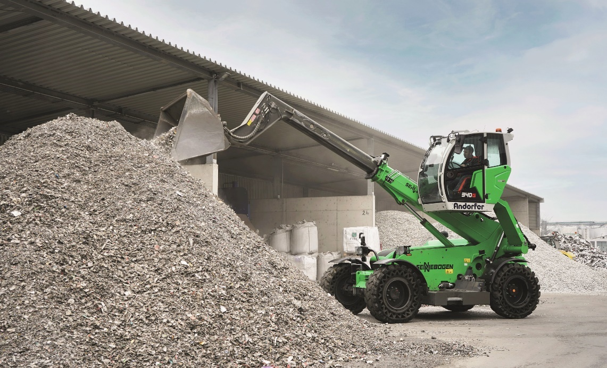

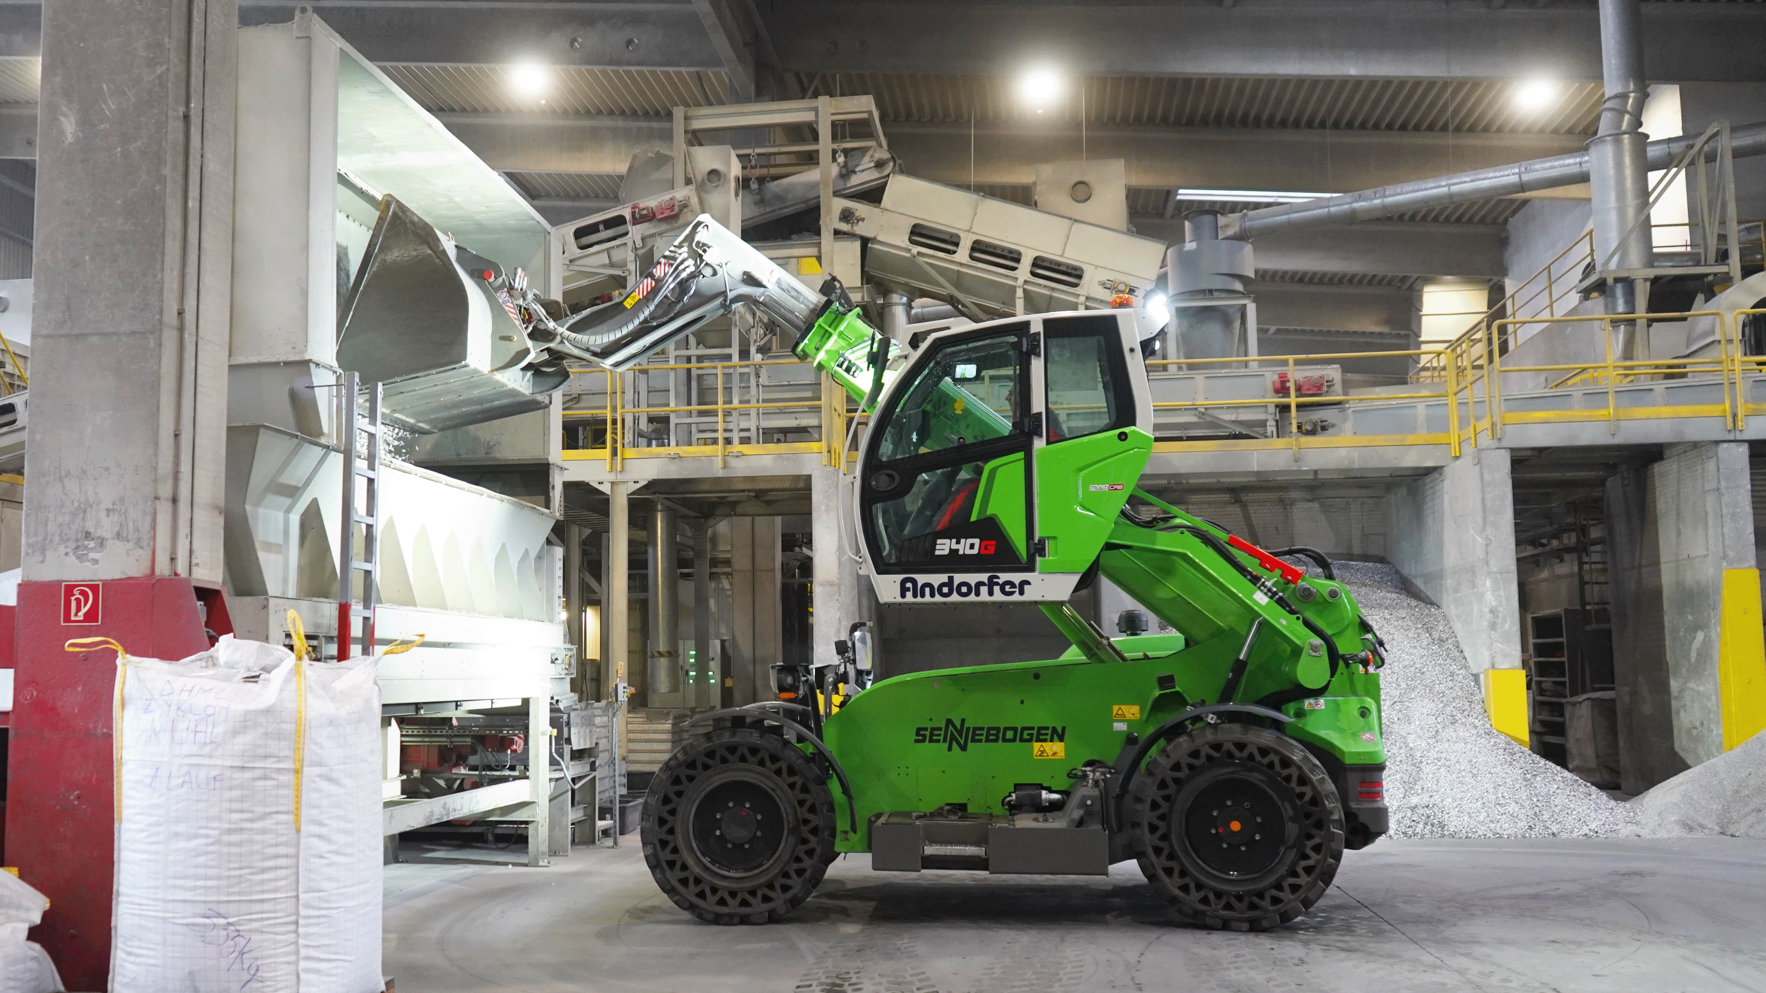
Extendable telescopic arm feeds filling tunnels effortlessly.
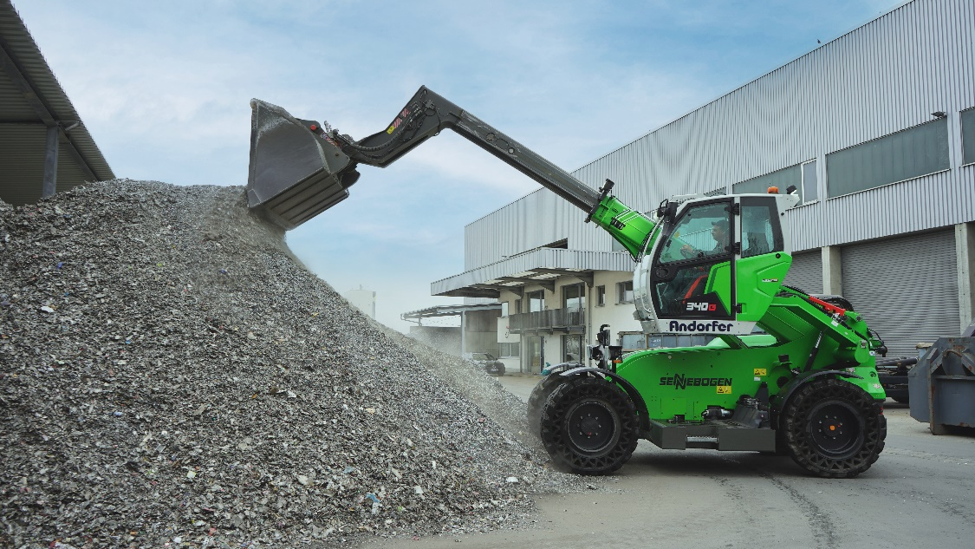
340 G’s standard reversible fan makes dusty conditions no problem.

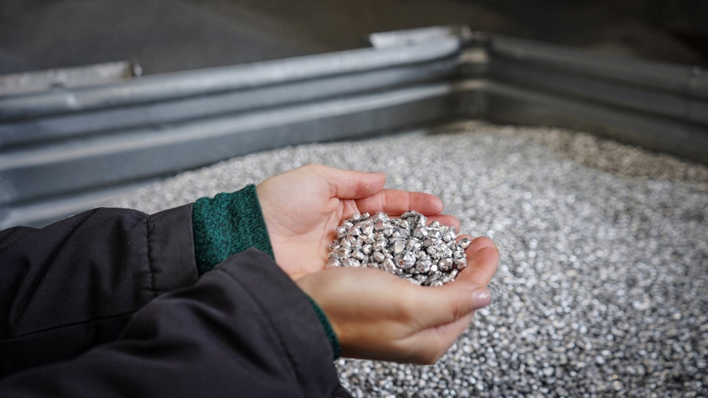
DESOX aluminum granules produced by Andomet that is used in steelworks.

