SENNEBOGEN telescopic crane 673 E proves itself once again on the Grand Paris Express construction site

The Grand Paris Express, a large-scale project to construct a new super metro, is Europe's largest infrastructure project to date. The SENNEBOGEN 673 E, part of ENCO's fleet, is being used on the future driverless underground railroad network for the second time already.

68 stations and a network of automated subway lines are expected to be completed by 2030, with around 90 percent being built underground. Planned length - around 200 kilometers. A SENNEBOGEN 673 E is currently in use again. It is on a Grand Paris Express construction site for the second time to take care of logistics and do the heavy lifting. The excavation work is being carried out by contractual partner organization "CAP" (managed by Vinci Construction, and involving BOTTE FONDATIONS and SPIE BATIGNOLLES FONDATIONS for special foundations works).
One of the future underground stations on the gigantic subway network will be located here. It will be a connection point between the “Line 15 South” of new Grand Paris Express ring and the existing "RER" suburban railroad.
One of the particular features of this station is that the excavation work sometimes needs to be carried out underneath existing tracks - quite a challenge for all involved.

Flexible from site to site: the SENNEBOGEN 673 E
The 673 E is part of the fleet on hire from construction machinery specialists ENCO. This new investment has been made to meet the needs of medium and long term construction sites. "There is a growing demand for telescopic crawler cranes in the French market, but only a few machines," says Thierry Bouvelot, Manager at ENCO. In order to be able to carry out the diaphragm wall work under the existing bridges on the construction site, the SENNEBOGEN 673 E is being used for all lifting procedures and, in particular, for the positioning of steel cages after drilling with a specially developed diaphragm wall grab and compact hydro rotary cutter. So that it can operate in complete safety under the bridges, the 186 kW SENNEBOGEN 673 E has been fitted with a special control system by SPIE BATIGNOLLES FONDATIONS and SENNEBOGEN's French sales and service partner SYGMAT. The telescopic crane's compact size means that, not only is it easy and cheap to transport, but also that it is ready to use very quickly after arriving on site, providing maximum flexibility on and between construction sites. Its entire fly boom is bolted to the main boom and hinged in two stages, meaning that hook heights of up to 50 m can be reached quickly and easily. This reduces setup time on the construction site. The tried-and-tested boom system with a full power boom provides maximum flexibility on the construction site. The new 673 R-HD is already equipped for the higher standards required by Stage 5 emissions levels.

Image caption:

The ENCO’s SENNEBOGEN telescopic crane 673 E proving itself once again for special foundations works on the Grand Paris Express construction site

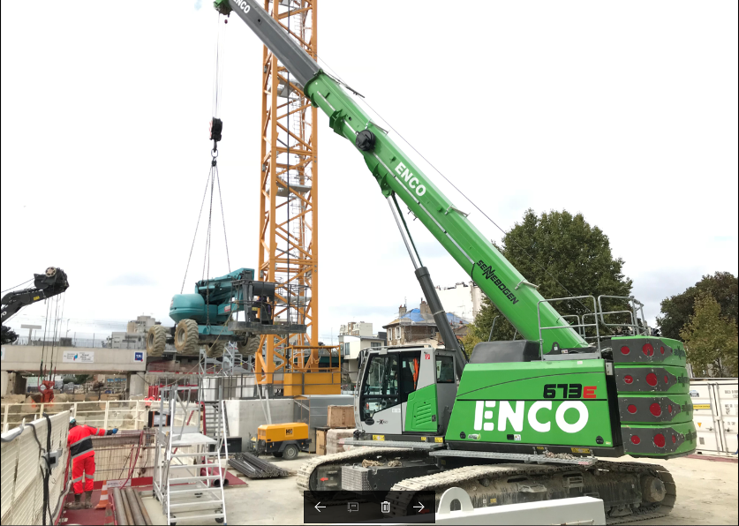

Please add those emblematic pictures in accordance with texts – “TPI” logo must be removed:
