**Editor** Autor**:** Sandra Hartl

**Photo** Foto**:** *SENNEBOGEN*

**Date** Datum**:** Sep-24

**Location** Ort**:** *Straubing*

**New generation of skilled workers: SENNEBOGEN honours 12 successful graduates**

**SENNEBOGEN recently honoured 12 apprentices for successfully completing their apprenticeship at a ceremony. The event emphasised the company's commitment to outstanding and modern training. Once again this year, some of the graduates were able to impress with excellent results in their examinations.**

‘Our trainees play a key role in the future of our company. That's why we continuously invest in state-of-the-art technology and equipment for our training workshops to ensure practical and up-to-date training,’ emphasised Torsten Resch, member of the management board, in his speech. The graduates were ceremoniously honoured for their achievements with certificates and gifts.

Once again this year, several graduates drew attention to themselves with outstanding achievements. Among the graduates, Anna-Maria Biendl, who completed her apprenticeship as an industrial management assistant as the best in her vocational school year, stood out in particular. Janina Meier, also an industrial management assistant, also received special recognition for her exceptional commitment as state student representative, a role in which she represents all vocational school students in Bavaria.

Also worth mentioning are the achievements of Erik Scharmann, who was honoured for his excellent school results as an IT specialist, and Simon Höchbauer, who passed his final examination as a technical product designer with the top grade of 1. In addition, Fabian Himmelstoß from the vocational school in Cham was honoured for his outstanding academic achievements with an impressive grade point average of 1.11.

‘It is a great pleasure for us to be able to honour exceptional achievements once again. This shows that we are able to attract motivated and talented young people to our company. It is even more pleasing that most of our graduates will remain part of the SENNEBOGEN family, ’ added Torsten Resch.

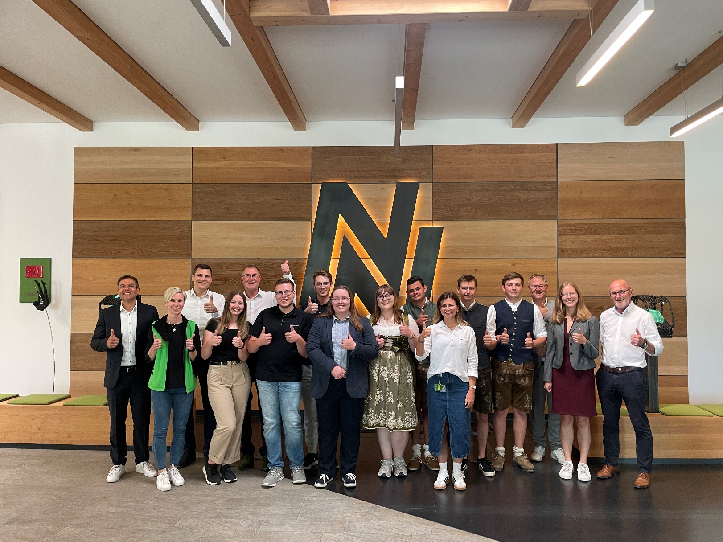

Management and those responsible for training congratulate all graduates on successfully completing their vocational qualifications.