Bild:
Date Datum: 2023
Location: UK
Photo Foto: Molson
Editor Autor: Molson Equipment Ltd.

Tree felling with tree care handlers: reducing road closures

Tree felling work in the context of traffic safety is in the spotlight, not least because of the increasing ash dieback in the UK. In view of the increasing spread of this tree disease, it is crucial to take preventative measures and at the same time ensure that tree felling is carried out safely. Ben Nicholson Tree Services is helping to reduce the impact of ash dieback and ensure road safety in the UK through the targeted use of SENNEBOGEN tree care handlers.

Ben Nicholson founded his company more than 20 years ago and, with his specialized fleet of machines including two SENNEBOGEN tree care handlers, offers a broad portfolio ranging from traffic safety to forestry work and the sale of forestry products. "The two SENNEBOGEN tree care handlers are much more effective and versatile than our previous machines," explains Ben Nicholson. "We initially used the 718 E with a reach of 13 m, which we were able to use for the majority of our jobs. However, we had to come up with something for larger trees in particular, so we also opted for a SENNEBOGEN 728 E with a 21 m reach. Now we can handle anything that comes our way."

Operator comfort and work safety thanks to elevating cab
The elevating cab in particular has proven to be a valuable addition to the daily work of both machines in the past, especially when felling problem trees in connection with ash dieback. "The elevating cabs give the operators an excellent view of the entire working area. We have configured both machines identically, so it's easy for our operators, including myself, to switch between the machines," confirms Ben Nicholson. The view from the SENNEBOGEN Maxcab is particularly good thanks to the variable elevation of up to 2.70 m and the inclination of up to 30 degrees. The special camera system also offers the operator a 360-degree all-round view, ensuring the safety of the entire team.

Use of SENNEBOGEN tree care handlers reduces job times and road closures
SENNEBOGEN tree care handlers are not only a technological innovation, they also make a significant contribution to efficiency in traffic safety. Thanks to their powerful equipment and precise control options, they enable tree felling to be carried out quickly, even for large jobs. "The majority of our jobs are carried out at the roadside. Using both tree care machines at the same time means that we can complete the felling work much faster and with shorter road closures," says Ben Nicholson. The fast and precise way of working therefore minimizes disruption to traffic, reduces the immediate impact on road operations and helps to keep disruption to road users to a minimum.

Routine maintenance can be carried out simply and easily at ground level
SENNEBOGEN machines are characterized not only by their high performance, but also by their maintenance-friendly design. The ground-level access to all maintenance points makes the maintenance process considerably easier and minimizes downtimes. Nicholson is also particularly satisfied with the SENNEBOGEN sales and service partner Molson Group, which is responsible for sales and more complex service work on the two tree care handlers.

[Caption:]
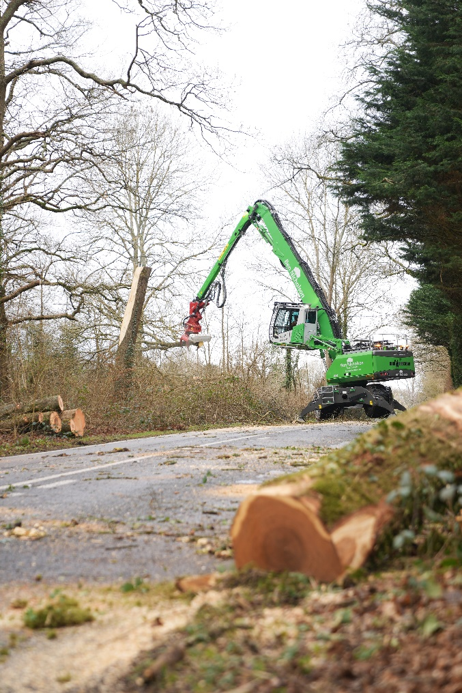
Traffic safety made easy with the use of SENNEBOGEN tree care handlers
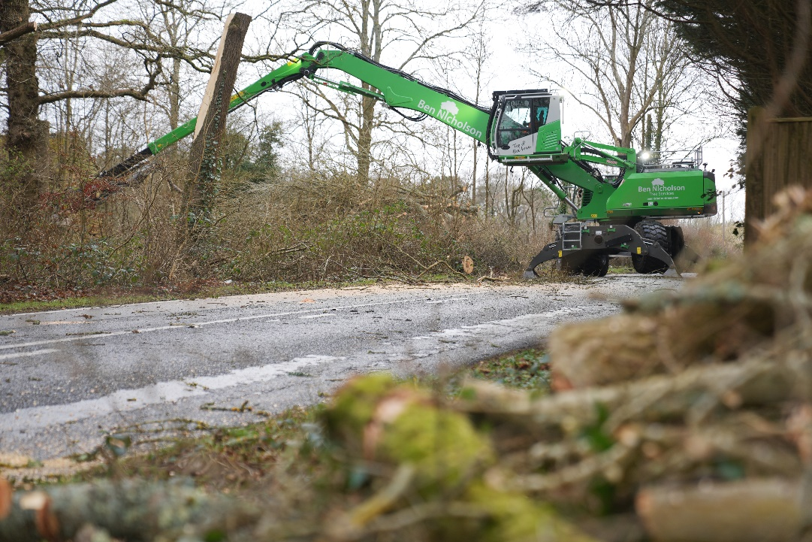
Impressive reach even for felling work in the second row
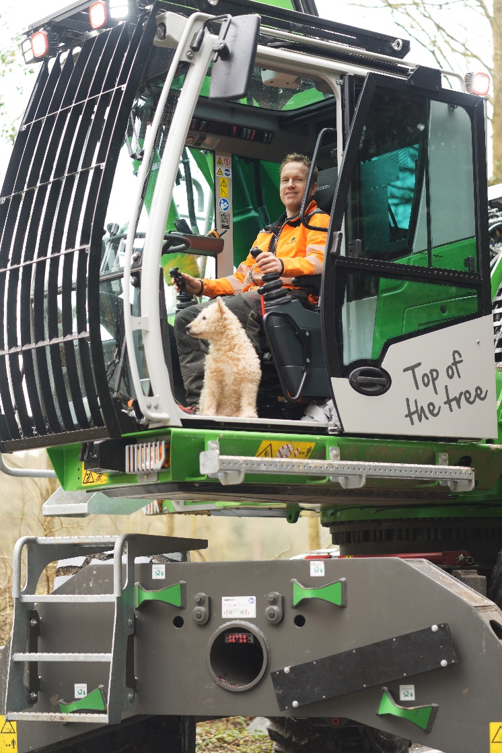
Ben Nicholson, founder of the company, is clearly satisfied with his SENNEBOGEN tree care handler

