SENNEBOGEN machines work as a team
355 telehandler and 818 E series material handler
Wood is a component part of many products and one of the most important renewable resources of our time. It is far too valuable to be left unsorted and sent to landfill. According to the Wood Recyclers Association, 4.5 million tons of waste wood are generated in Great Britain every year. One customer of the SENNEBOGEN dealer Molson Group in England has taken on this problem and recycles waste wood with the help of two SENNEBOGEN machines: the 818 E and the 355 E. The mobile material handler and the telehandler work seamlessly hand in hand.

It is early morning and on premises, near to Coventry in England, work is already underway. One truck after another drives into the delivery area loaded up with valuable cargo. It is waste wood, presorted for further processing. With the help of a shredder, different sizes of valuable raw material will be created from the discarded pieces.

The mobile material handler 818 E from SENNEBOGEN is used to load the shredder with bulky pieces of wood that are brought over by the 355 E telehandler. Equipped with an elevating comfort Maxcab, the 818 E's operator has a great view of the shredding plant at a viewing height of 5.50 m. "Thanks to the elevating cab I can see straight away if the material is building up in the shredder filling shaft and I can intervene if necessary. The cab is also very spacious and comfortable," says the operator. The non-slip platform and the railings by the entry provide additional safety on the way up to the cab and on the way back down. An additional protective guard on the windshield and floodlights on the equipment also contribute to a safe environment for the operator.

While the material handler is loading mountains of waste wood into the shredder in a fast work cycle, the SENNEBOGEN 355 telehandler carries out various other tasks. These include moving the wood supplies to within the reach of the material handler and keeping the yard tidy. However, its main job is transporting the chopped wood pieces to the storage area and stacking them up there. There are three stacks, sorted by the size of the material. They range from coarse woodchips to fine sawdust, which, amongst other things, is reused in pellet form as bedding for house pets. The large bucket, which has a loading capacity of 4 m³, means the operator can get the job done quickly and with fewer trips.

Dusty environment - consistent reliable performance
You cannot shred without creating dust. Anyone who has worked with wood will know how very fine sawdust is and how it gets absolutely everywhere. The risk it poses to humans and machines in day-to-day work should, therefore, not be underestimated. On the one hand it is not healthy for humans to, for example, breathe in the particles, and on the other hand a buildup of deposits in filters or engines can pose a fire risk.

In order to best protect not only the machine, but primarily the people too, SENNEBOGEN machines have series standard equipment that provides benefits for both. The SENNEBOGEN 355 E telehandler has a series standard reversible fan which means that the engine area can be regularly freed of dust and dirt by means of a strong blast of air from the outside. This ensures the engine maintains its optimal cooling capacity and protects it from overheating, keeping it productive and reliable.

The operator themselves is protected from various environmental influences by the Multicab on the 355 E telehandler and the Maxcab on the 818 E material handler. Whether it is raining, cold, hot or dusty, thanks to the series standard air-conditioning, the operator can concentrate on their work without distractions in a cab adjusted to the temperature that suits them best. The telehandler's elevating cab also provides a bonus when it comes to visibility. "When I'm loading and stacking material, I have a great view of what's going on both in front and behind, and I can adjust my angle of vision to my requirements without cricking my neck. When traveling, the elevated cab remains stable and doesn't judder. The air suspension does a really good job," says the operator of the 355 E.

These and other features, such as the large steel design and the telehandler's large breakaway torque at wheel loader level, ensure smooth operation when processing wood even in multi-shift operations.
The SENNEBOGEN sales and service partner Molson Group and their customer are delighted that the 355 E and the 818 E make such a good team.

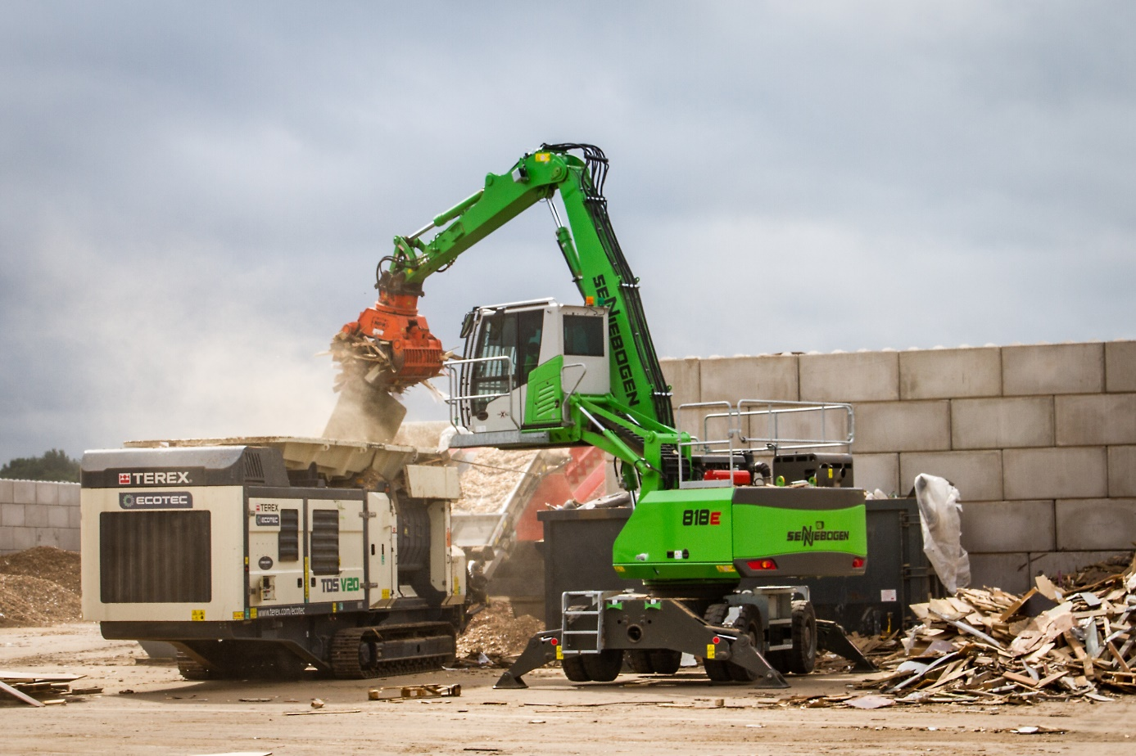
The elevating cab means that the operator has a perfect view into the shredder

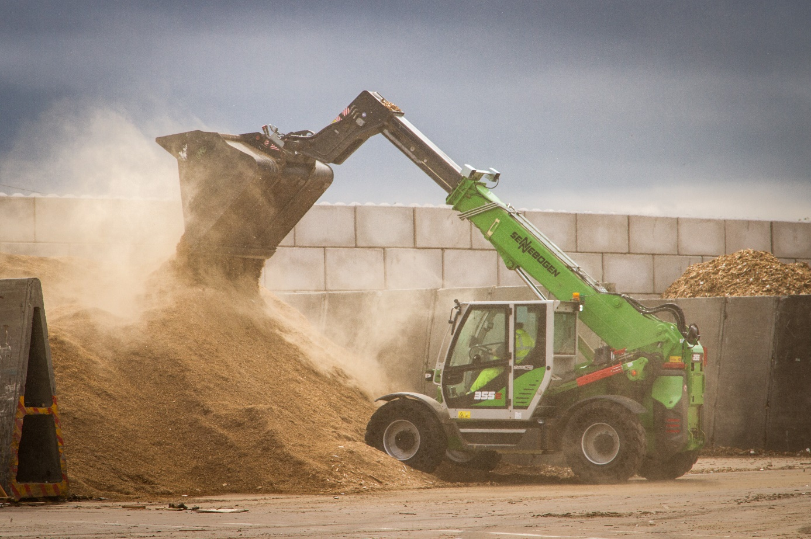
The series standard reversible fan ensures a consistent performance in a dusty environment

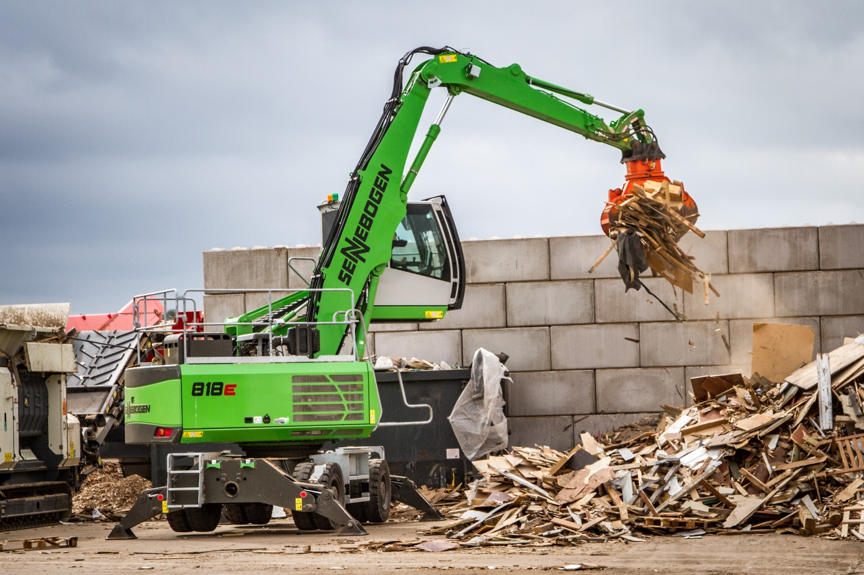
Secure footing whilst loading the shredder thanks to a wide support base

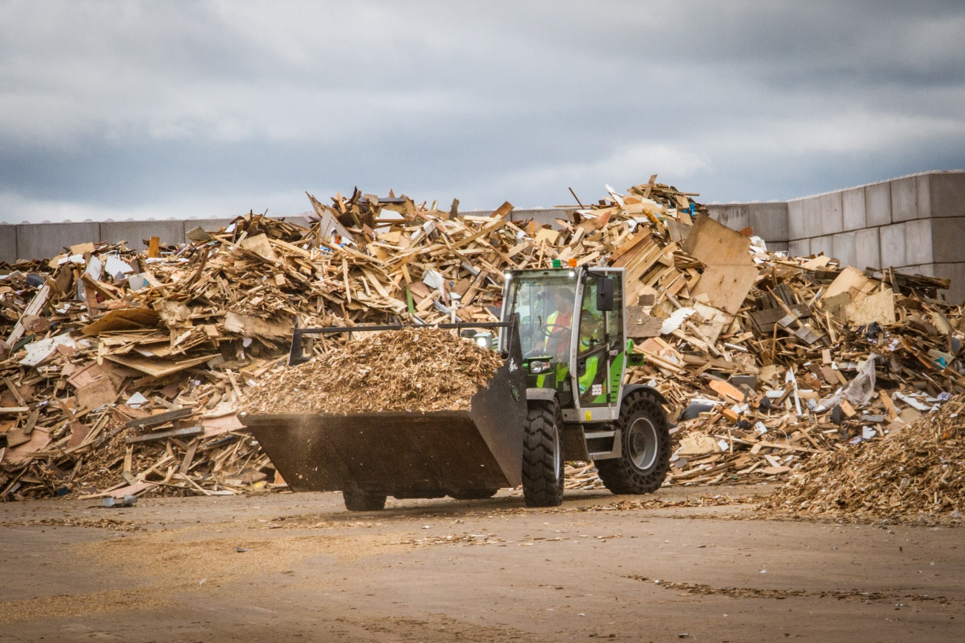The ample 4 m³ bucket means the shredded material can be loaded quickly.

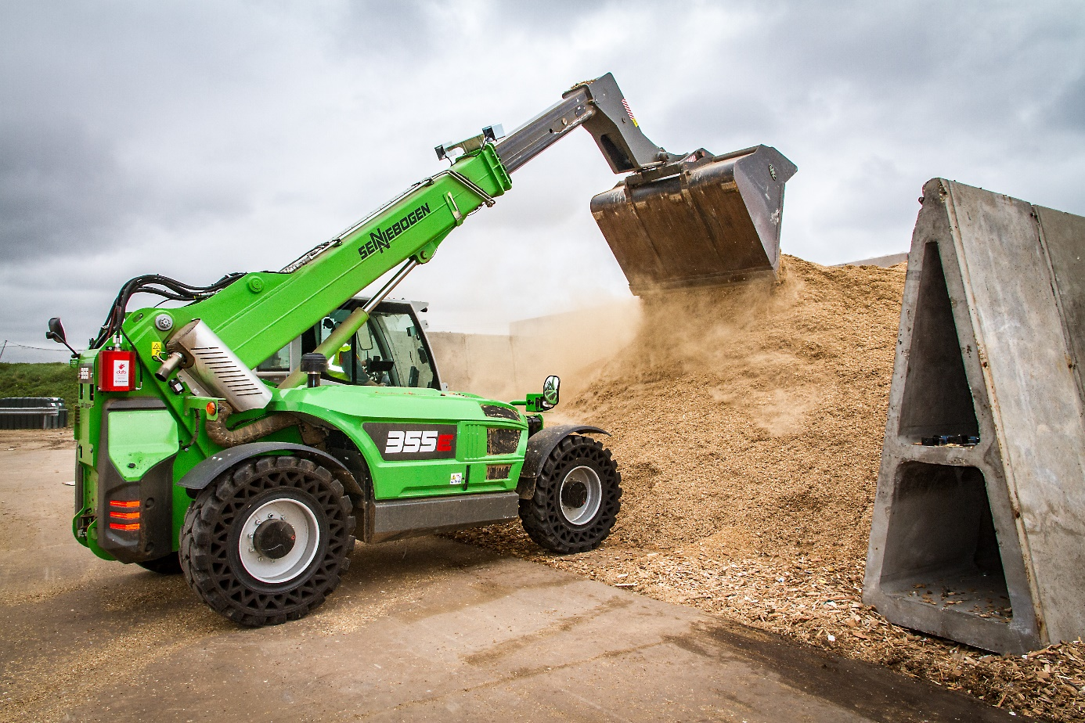
The strong telescopic boom on the 355 E is perfectly suited to piling up material.

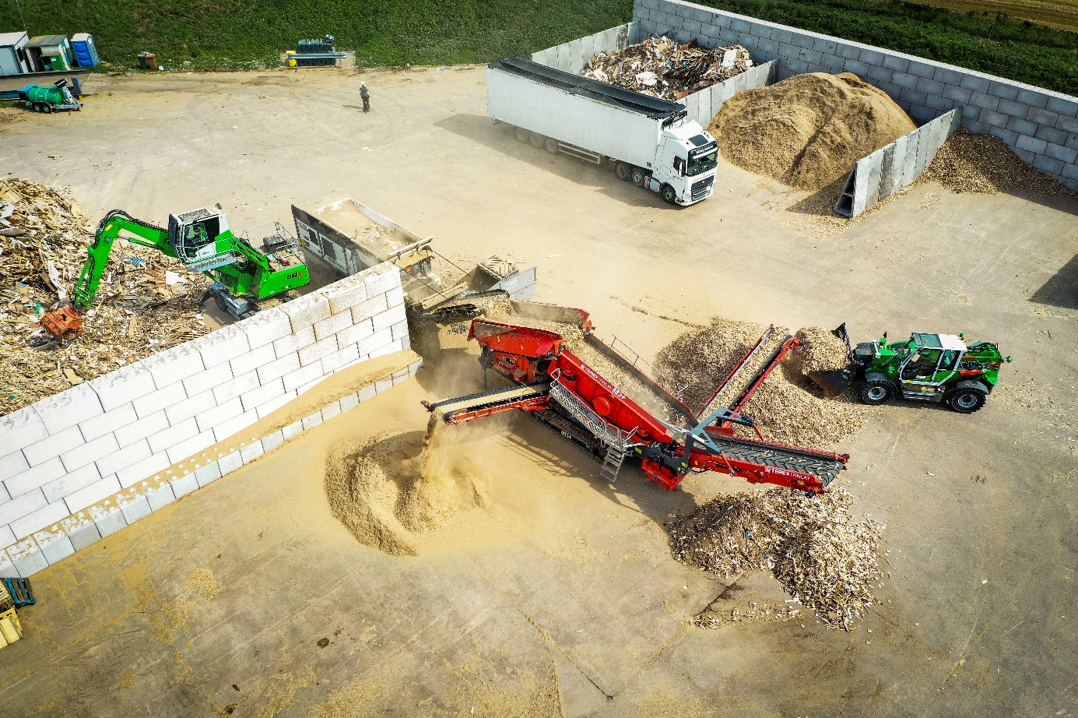
Two SENNEBOGEN machines, the 818 E and 355 E, working together

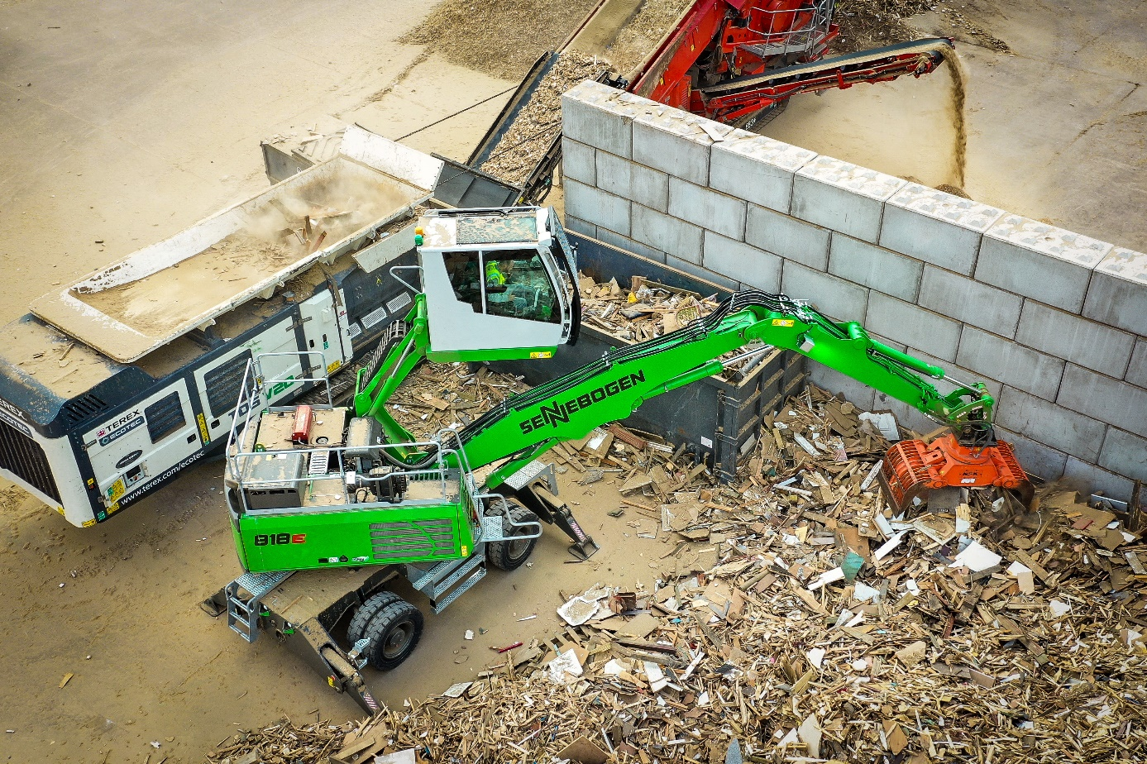
Precisely sorted material thanks to sensitive equipment controls

