Allrounder for Scotbark: SENNEBOGEN 355 E telescopic handler in Great Britain
Scotbark LLP is a Scottish company based in Glasgow with 30 years' experience in manufacturing and distributing premium bark mulch. Over time, Scotbark's product range and customer base have increased massively and the company has become a comprehensive supplier of garden and landscaping materials.

For the past 10 years, two SENNEBOGEN 305 machines have done the majority of the loading and stacking work. Now a third machine has been added - the first of the new "Multi Line" product range, redesigned from the ground up, the SENNEBOGEN telehandler 355 E. It is the first operational 355 E in Great Britain and is supplied and serviced by SENNEBOGEN dealer Molson Green.

So, how does the 355 compare to conventional telehandlers? Having got behind the wheel, Scotbark's impression is that there is a lot more power at play!
The SENNEBOGEN 355 E combines the best features of a wheel loader and a telehandler in one machine. It is strong and robust like a wheel loader but, at the same time, sturdy and stable like a telehandler. The "Z-kinematics" usually associated with a wheel loader provide very high breakaway force and mean that the bucket can deal effortlessly with the mountain of bark mulch on the Scotbark site.

Michael Boyle, Managing Director at Scotbark: "The SENNEBOGEN 355 E is exactly the right machine for our company - we needed a telehandler with wheel loader capabilities to successfully carry out our busy operations. With the 355 E, we can turn customer orders around really quickly as it is in operation pretty much constantly, dealing with both incoming orders at night and handling things during the day." The telehandler lives up to the name of the product range "Multi Line" and can be fitted with a lifting fork in seconds thanks to the series-standard hydraulic SENNEBOGEN quick-change system. This means it is equipped for multi-functional tasks.

Scotbark is particularly impressed by the large loading capacity of the hold-down shovel which can scoop up to 3 m³ of material. This considerably speeds up the loading of bark mulch. Another great feature is, of course, the exclusive elevating cab, the SENNEBOGEN Multicab, as Michael Boyle says, "The 355 E has the right bucket capacity for loading everything quickly, from bulk bags to pickup trucks to our largest 100 m3 walking floor trailers. In addition, the elevating cab with its all-round view provides an unsurpassed level of occupational safety in our busy yard."

The operator of the 355 E at Scotbark, Ben Lang, is enthusiastic too. "When I am sat almost 4 meters above ground level, I don't have to strain my neck to load high-sided vehicles. It's not just the direct view provided by the elevating cab that's great - the mirror package and the rear-view cameras are also brilliant for operator comfort because they mean that I don't have to turn my head so often to check for obstacles behind me."

The SENNEBOGEN 355 E's small turning radius of less than 4 m is important for being able to work in tight spaces and deal efficiently with a line of waiting trucks. Thanks to its perfect balance of power and speed, the 355 E was predestined for the demanding loading work it carries out at Scotbark.
As Ben Lang summarizes, "Compared to conventional telehandlers, the 355 E is the perfect machine for this work. There are so many factors that mean it is playing in a completely different league - its power, smooth control, maneuverability, outstanding breakaway force and the excellent view from the elevating cab."

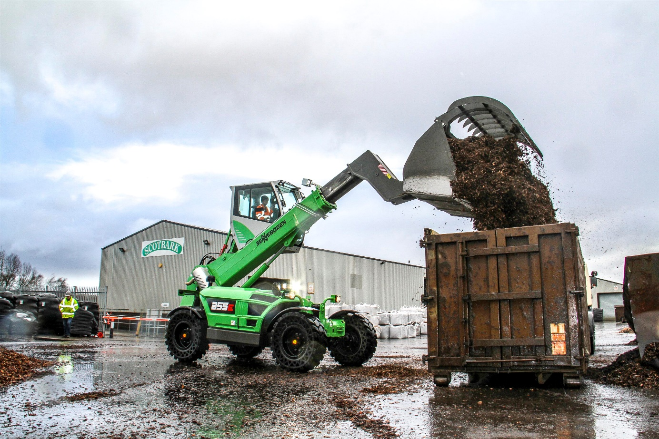
The elevating cab provides the perfect view for loading

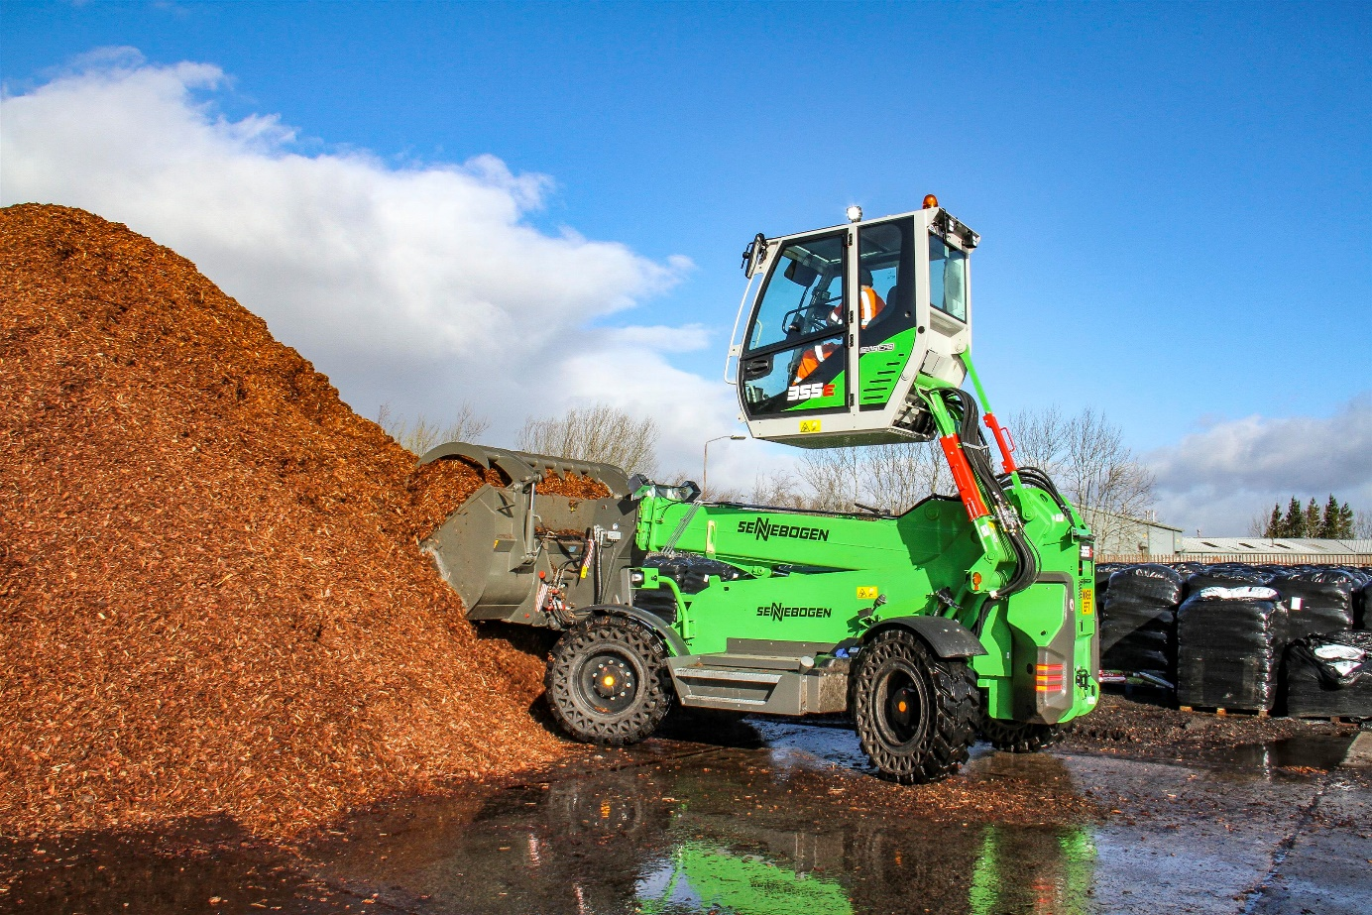
The Z-kinematics guarantee effortless filling of the hold-down shovel

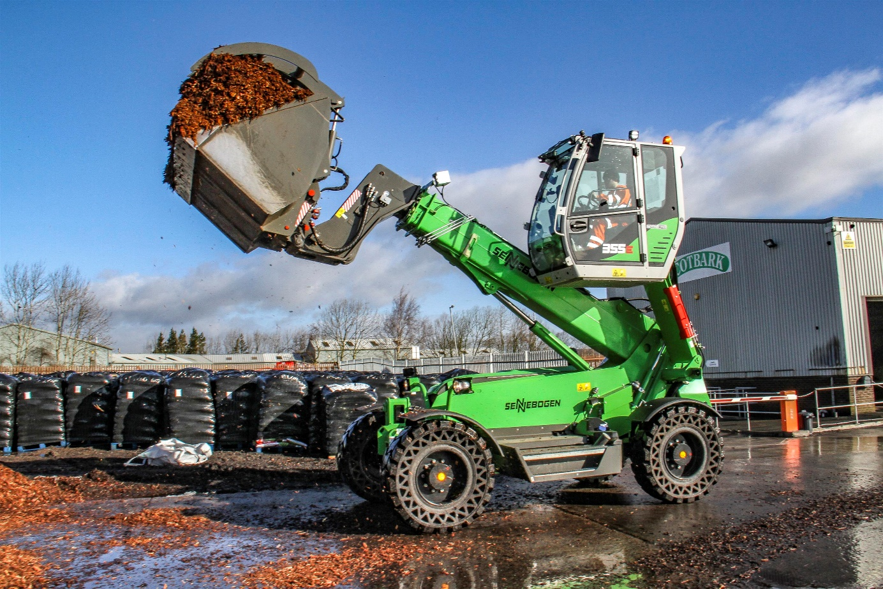
Efficient work thanks to the large bucket capacity and the small turning radius

