Bild:
Date Datum: Mai-22
Location Ort: Germersheim, DE
Photo Foto: Niklas Kühle
Editor Autor: Niklas Kühle, Franziska Brielbeck

SENNEBOGEN 355 E Telehandler: Clearly a matter for the boss at Freyer GmbH in Germersheim

Freyer GmbH is a family business in the 4th generation and has been carrying out port handling operations and the storage and transport of bulk and general cargo since the port of Rheinhafen Germersheim was founded. The company has now invested in a 355 E for various all-round work and transport around the port site.

SENNEBOGEN 355 E completes the fleet at Freyer
Freyer GmbH already had a broad machine portfolio for its cargo handling of up to 500,000 t per year: Material handlers, cranes, wheel loaders and forklift trucks work on the port site every day. However, the company still needed an all-rounder that could be used for various tasks at different locations. With the 355 E telehandler from SENNEBOGEN, Peter Freyer has found the missing piece of the puzzle for his fleet.

The machine is primarily available to the boss. “The 355 E is my vehicle that I drive through the site every day. This allows me to protect my car and carry out smaller jobs at the same time.” Since Freyer GmbH frequently works with scrap and pig iron, the telehandler was equipped with puncture-resistant, airless tires to prevent damage when driving through the port area.

The SENNEBOGEN 355 E also has a quick-changer with which Peter Freyer can quickly and easily replace his existing equipment from the driver’s cab at the push of a button, for example to carry out forklift work.

Powerful telehandler with unique features: Freyer appreciates the elevating cab
To make loading ships for the rope cranes as easy as possible, Peter Freyer stacks the scrap material to high piles on the quay. The 355 E from SENNEBOGEN combines the advantages of a telehandler and wheel loader and is therefore ideal for this task: Thanks to the robust steel construction of the telescopic arm with a lifting height of 8.5 m, the ideal transfer of power to the shovel using the Z kinematics and the powerful drive train with infinitely variable travel drive, this type of work can be carried out easily. At 5.5 t, the telehandler’s load capacity is significantly higher than that of other machines in this weight class, and with a turning circle of less than 4.5 meters, the 355 E from SENNEBOGEN’s is also ideally suited to work in confined spaces.

Safety due to overview
Of course, the telehandler does not compromise on safety either: Thanks to the elevating cab to 4.25 m and the 360° all-round view thanks to large glass surfaces, Peter Freyer has a very good view of all four sides of the machine and his working environment at all times. “The elevating cab gives me a very good overview, with hardly any blind spot. Particularly if I have to work on the right side, I can align the cab so that I always have a clear view. It’s simply a pleasant and safe way of working.”

Reliable partners: Freyer GmbH and Schlüter für Baumaschinen
The SENNEBOGEN 355 E telehandler was delivered by Schlüter für Baumaschinen.
The company is always on hand to support Freyer GmbH and Managing Director Peter Freyer as a reliable partner. “The premium machines from SENNEBOGEN in combination with the advice and service from Schlüter für Baumaschinen, are simply a package that suits us very well,” states Peter Freyer, Managing Director of Freyer GmbH.

Captions:
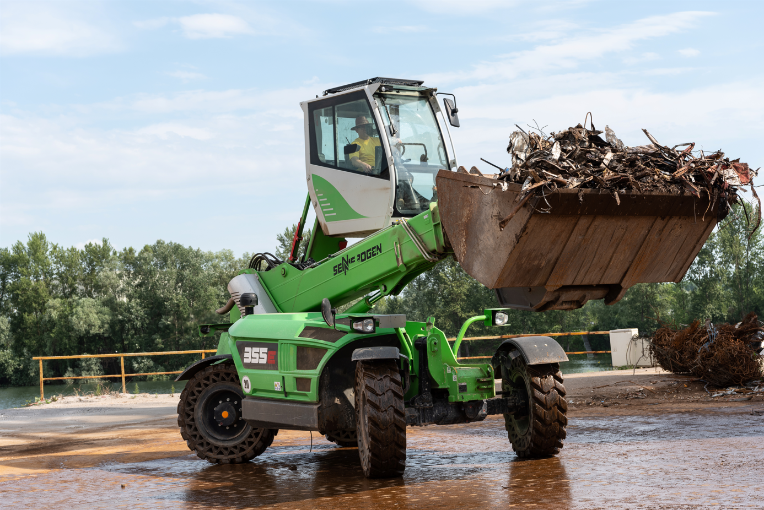

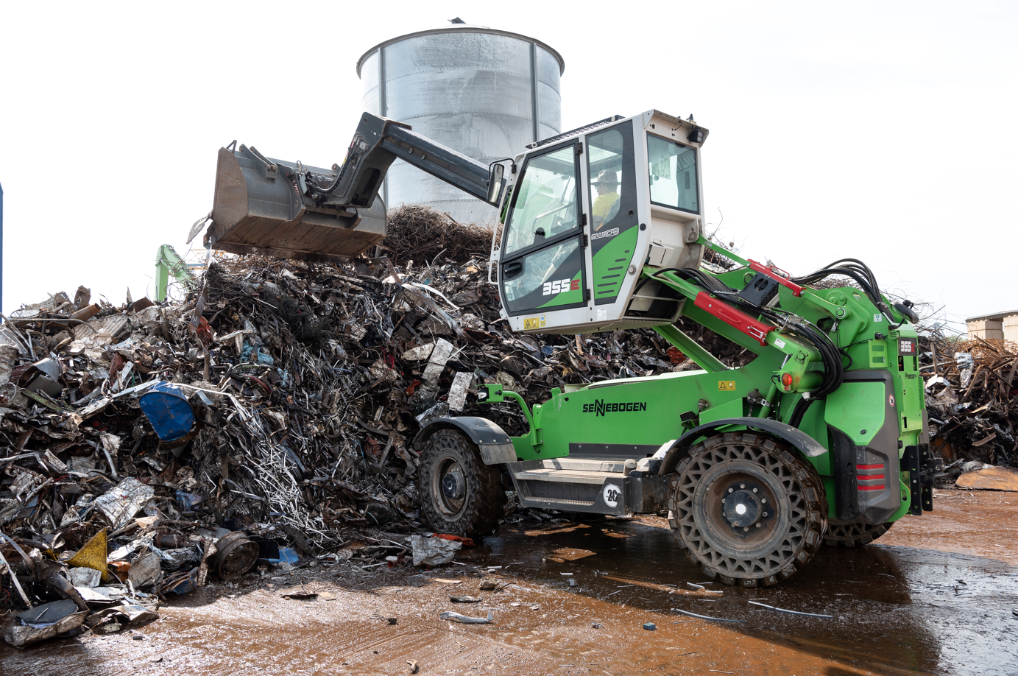

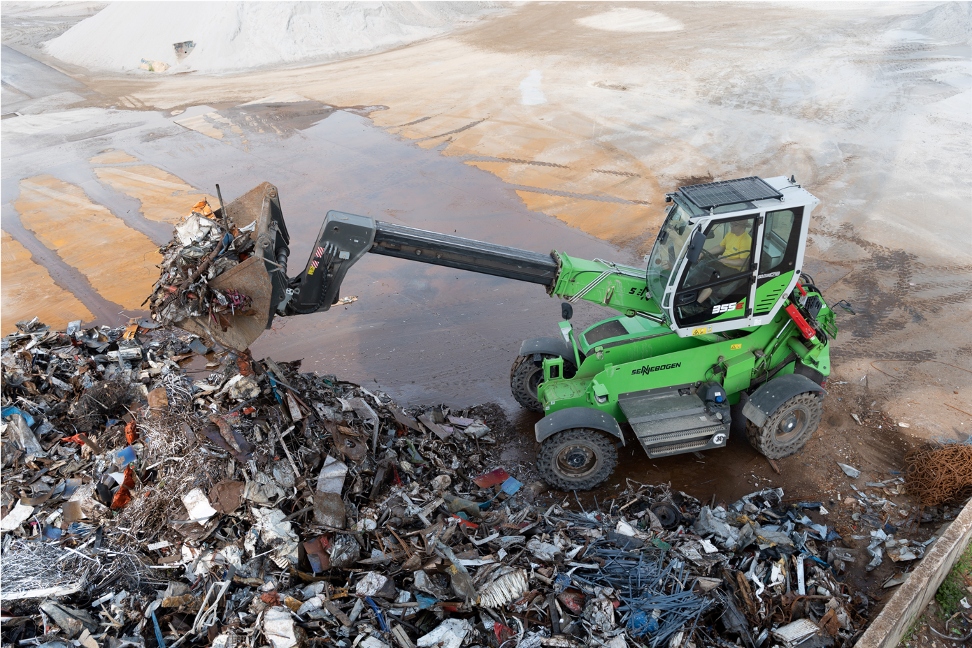

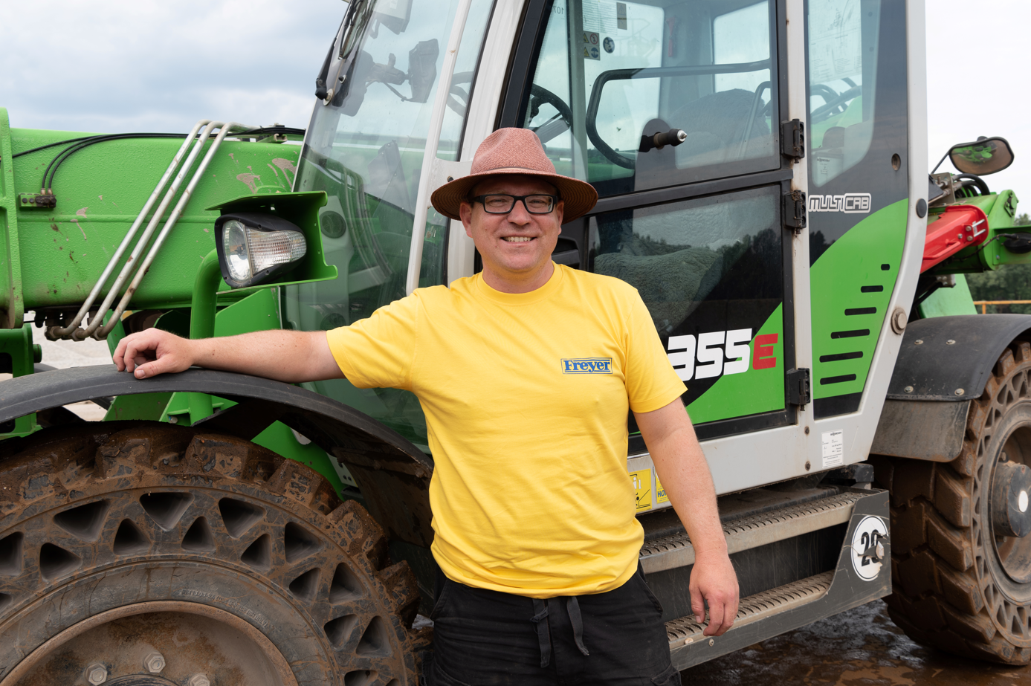
Peter Freyer, Managing Director of Freyer GmbH, with his new 355 E telehandler from SENNEBOGEN.

